Accounting Hub – Technology Simplification (IT Resilience) - Mid-Level Platform Design
Version 2.4
Document of Control
The completion of this sheet represents the document history.
Document Modification Control:
Date | Author | Role | Version | Comments
18//08/2014 | Krishna Dattatreya | Architect, ADM – Payments | 0.1 | Draft Version based on AD document,  GO-186899-Technology Simplification - Accounting Hub-AD Ver. 0.2
19//08/2014 | Krishna Dattatreya | Architect, ADM – Payments | 0.2 | Added Use cases
22/08/2014 | Krishna Dattatreya | Architect, ADM – Payments | 0.3 | Added Account Enquiry
26/08/2014 | Krishna Dattatreya | Architect, ADM – Payments | 0.4 | Added Account Posting
28/06/2014 | Krishna Dattatreya | Architect, ADM – Payments | 0.5 | Added Accounting Hub Platform enhancement (MicroKernal Architecture)
04/09/2014 | Krishna Dattatreya | Architect, ADM – Payments | 0.6 | SME Review comments implemented.
12/09/2014 | Krishna Dattatreya | Architect, ADM – Payments | 0.7 | Update MLPD as per AD document ver0.34
19/09/2014 | Vinoth Krishnamoorthy | ADM Payments SME | 1.0 | Reviewed and signed-off v0.7, sent for EAD review, baseline version 1.0
25/09/2014 | Krishna Dattatreya | Architect, ADM – Payments | 1.1 | Updated with Transaction Context Management – section 3.5, sent for SME review
29/09/2014 | Vinoth Krishnamoorthy | ADM Payments SME | 1.2 | Reviewed and signed-off v1.1, sent for EAD review, added section 3.4.4 for batch posting, modified section 3.8 Information model
07/10/2014 | Krishna Dattatreya | Architect, ADM - Payments | 1.3 | EAD Review comments implemented.
07/10/2014 | Vinoth Krishnamoorthy | ADM Payments SME | 1.4 | Swapped sections 3 & 4, redone Microkernel implementation section, added AIS and APS implementation model on MK
08/10/2014 | Vinoth Krishnamoorthy | ADM Payments SME | 1.5 | Added Info model diagram, Infra diagram and state machine diagram, final revision to EAD
13/10/2014 | Vinoth Krishnamoorthy | ADM Payments SME | 1.6 | Final changes to section 3 – defining state models, component realisation
14/10/2014 | Krishna Dattatreya |  | 2.0 | Base line version  
11/05/2015 | Krishna Dattatreya | Architect, ADM - Payments | 2.1 | Updated with CR 17
12/05/2015 | Krishna Dattatreya | Architect, ADM - Payments | 2.2 | Updated with CR 18
14/05/2015 | Krishna Dattatreya | Architect, ADM – Payments | 2.3 | SME Comments updated
25/06/2015 | Krishna Dattatreya | Architect, ADM – Payments | 2.4 | Updated as pe CR18 v1.3 changes

Document Review
Date | Reviewer | Role | Version | Comments
19/09/2014 | Vinoth Krishnamoorthy | Accounting Hub, STP SME | 0.7 | v0.7, sent for EAD review, baseline version 1.0
29/09/2014 | Vinoth Krishnamoorthy | Accounting Hub, STP SME | 1.1 | Reviewed and sent comments to rework on section 3.5
08/10/2014 | Vinoth Krishnamoorthy | Accounting Hub, STP SME | 1.3 | Reviewed and modify, sent for final EAD review
08/10/2014 | Stuart Mason | Accounting Hub, SME | 1.3 | Reviewed and modify, sent for final EAD review

Document Approval/Signatures
Date | Approver | Role | Version | Signature
 | Vinoth Krishnamoorthy | Accounting Hub, STP SME
 | Sarit Seal | EAD SA
 | Ramdas Gawande | EAD SA
 | Alister Lees | GITO PM

Distribution List:
Name | Role | Team | Comments
Jeeten Shah | Senior DSM
Alister Lees | GITO PM
Rohit Devagan/ Sivagnanam, Praveen | DSM
Table of Contents
1 Introduction 8
1.1 Background 8
1.2 Audience 9
1.3 Purpose of this document 9
1.4 Change Request 9
1.5 Scope 10
1.5.2 Out of scope 10
1.6 Reference 11
1.7 Assumptions 11
1.8 Risks 12
1.9 Dependencies 12
2 Service Functionality 13
2.1 HBOS Platform - Accounts Enquiry 13
2.2 HBOS Platform - Posting Service 13
2.3 Account Enquiry 16
2.3.1 Use Case– Account Enquiry 16
2.4 Account Posting 19
2.4.1 Use Case – Account Posting 19
2.5 Traceability 24
3 Accounting Hub Platform Enhancement 25
3.1 Accounting Hub – State models based on Microkernel pattern 25
3.1.1 Synchronous request-response model 27
3.1.2 Asynchronous request model 27
3.1.3 Asynchronous response model 27
3.1.4 Group Control – Fan-out model 27
3.1.5 Group Control – Fan-in model 28
3.1.6 State Model Design Elements 28
3.2 Accounting Hub – Component Model 30
3.3 Accounting Hub – Component Realisation 33
3.4 Accounting Hub – Block Architecture 34
3.5 Accounting Hub – Services Realisation 35
3.6 Accounting Hub – State Transition 37
3.7 Microkernel – Design limitations 38
4 Design 40
4.1 System Context Diagram 40
4.2 Architecture Overview 40
4.3 Account Enquiry 40
4.3.1 AIS Processing steps - Activity Diagram 40
4.3.2 AIS processing steps - Sequence Diagram 43
4.3.3 AIS Implementation model 44
4.4 Account Posting 45
4.4.1 APS Processing Steps - Activity Diagram 45
4.4.2 APS Processing Steps – Sequence Diagram 48
4.4.3 APS Implementation model 49
4.4.4 Inter platform Posting 50
4.4.5 Batch Posting 52
4.5 Transaction Context Management 59
4.6 Non-Functional Requirements 64
4.7 Component Details 65
4.7.1 New Component Details 65
4.8 Interfacing with TMS – Alerting NPA Failures 68
4.8.1 Frame Work Changes 68
4.8.2 Alerting - Activity Diagram 69
4.9 AMD Interface Changes and TD01 Posting Orchestration. 70
4.10 Information Architecture 71
4.10.1 IFW – Request Layout 72
4.10.2 IFW – Response Layout 72
4.10.3 Batch Posting – Message Layout 72
4.10.4 AMD – Request and Response getAccountInformation 72
4.10.5 AMD – Request and Response getNPADetails 72
5 Error Codes 73
5.1.1 Response Code/Message 73
6 Security 74
7 Scheduler and Mainframe 75
7.1 BAM Monitoring 75
7.1.1 Requirement 75
7.2 Operations Monitoring 75
7.2.1 Requirement 75
7.2.2 Implementation 76
7.3 Exception Handling 76
7.3.1 Requirement 76
7.3.2 Exceptions Data Store 76
7.3.3 Implementation 76
7.4 Auditing 77
7.4.1 Requirement 77
8 Infrastructure Design 78

Glossary of Terms
Term | Explanation
TMH | Transaction Management HUB (D4)
APS | Account Posting Service
AIS | Account Information Service
AMD | Account Master Data
rCBS | Retail Core Banking System
TODS | Transaction Online Data Store
wCBS | Wholesale Core Banking System
OCIS | Online Customer Information System

Introduction

Background
The strategy is to use Accounting hub as a facade for the product platforms both for account enquiry and account posting to the external consumers. It also acts as a gateway to the product platforms as it hides the complexity of the consumers, schemes, and transactions. This strategy benefits the Bank/Global Payments Line of Business, by abstracting the payment engines from the product platforms. Hence there is a potential case of re-use. The programme benefits through economies of scale
Accounting hub will be the single channel through which the account posting will be forwarded to the product platforms. Hence the payment engine will send product platform agnostic posting request to accounting hub. Accounting hub will identify the correct product platform and invoke the appropriate interface on the product platform. Accounting hub will also maintain all necessary reference data required for account posting to the product platform. This solves the problem of data duplication, impact due to account migrations, and interface changes on the product platforms.
Technical problems were experienced by the Royal Bank of Scotland Group (RBSG) in mid 2012. Following the problem, Group Operations Risk, supported by Group IT, and initiated The IT Resilience Review with the purpose of identifying the IT resiliency of LBGs Critical Business Processes (CBPs). Price Waterhouse Coopers (PwC) was invited to conduct an independent review of the IT resiliency of LBG’s CBPs and identified 36 CBPs categorised as either Category A, B or C with different availability and recovery time objectives across 19 key themes. One of the key themes was Age and Complexity and this project is one of a number that will reduce the resilience risk associated with the identified CBPs.
The direction is the Payments engines in the HBOS legacy will be decommissioned and the traffic will be routed to the Lloyds Payments engines (Ex: LCS, STP etc). As per strategy Payments engines will not directly send the postings to the hHBOS product platforms, rather the postings and enquiry requests will be mediated through Accounting hub. Hence the interfaces to the product platforms are being built in Accounting Hub. The scope of this project is to build the interface to the HBOS product platforms. The interface built will be a generic interface to the product platforms.
As per the HBOS decommissioning project under Technology Simplification Age & complexity the scope is to decommission the hHBOS Payment engines and route all the inbound and out-bound payments through the Lloyds payments engines. The Lloyds Payment engines (aka LCS, Common System, STP) will use Accounting hub to identify the product platform, and will route to accounting hub for posting to the hHBOS product platforms. The primary guideline is to reuse the existing interfaces on the hHBOS platforms this approach reduces development on the fated systems

Audience
This document is intended for the following audience:
- TDA's to verify that the design meets the Accounting Hub design standards and vision. Also ensure the design meets recent changes to standards in terms of tooling and approach like usage of IBM RSA, RUP, etc. Functional aspects of the new design should also be verified and approved to cover existing / future payment related business functions normally part of STP or other payment engines, e.g. SCAR, e-Payments, BACS, FP, etc.
- Peer platform designers to verify that this design is consistent with their Mid Level Platform Design.
- EA&D to verify that the platform design is consistent with the Architecture Description Document.

Purpose of this document
This document presents drilled down details of the interfaces, operations, components and sub-components of HBOS Platform Account postings that will act as façade to systems of record holding account information.

Change Request

- CR17 - Accounting Hub Changes – Alerting NPA Failures
There is a requirement to report exceptions to the business when there is a failure to post to a NPA (however the customer part of the transaction has processed correctly ). Transaction Bus (FTM) Design Authority (TDA) rejected FTM to report these errors for non-FTM activities, specifically the failure of transaction posting due to account platform failure, rather than Accounting Hub failures. This has resulted in a gap in the end to end solution specifically for postings to NPA accounts where they reside on a different accounting platform to that of the payment (e.g. customer account wCBS, NPA rCBS).
These changes will cover both CHAPS and International account postings which will be posted from Transaction Bus (FTM) to Accounting Hub as part of TS2. This will include Treasury CHAPS payments also
Refer to section 4.8 for detailed design.
- CR 18 – Changes to address the issues of incorrect postings, reconciliation, and statement narratives
In order to make the postings to hHBOS product platforms, some changes are required in FTM, Accounting Hub and AMD, which will address the issues of incorrect postings, reconciliation, and statement narratives.
These changes are required for Transitional State 2 (TS2 – planned implementation 02/10/2015). These changes will cover:
- Both CHAPS and International account postings which will be routed from LCS-Transaction Bus-Accounting Hub as part of TS2. These are treated as inbound payments from Accounting Hub perspective.

- CHAPS outbound payments which are intiated from COL and IF Mid-Tier channels as part of TS2. These are treated as outbound payments from Accounting Hub perspective
Refer to section 4.9 for details

Scope

In-scope
ID | In-Scope
1 | HBOS Product platforms – NCA, wCBS, TD01, IF-TD01,IF-Lynx and LTSB Platform – rCBS for Inter platform settlement account posting.
2 | For Account Enquiry the scope is to identify the product platform for the incoming Sort code and Account number.
3 | Online Account Posting to HBOS Product platforms.
4 | Batch Account Posting to HBOS Product Platforms via Transaction bus
5 | Process unprocessed messages held in failed nodes. A new node monitor/heart-beat flow will be added to consolidate node status.
6 | Remove OCIS from core services call as this will be handled by AMD
7 | Inter platform posting
8 | Aggregation Function: Accounting Hub will aggregate group of posting entries to create batch or aggregated posting, The use case for aggregation will be HOCA model where individual postings are lotted to a single NPA account online.
9 | Creation of scheduling flows for managing batch posting and aggregation
10 | Alerting NPA Failures
Table 1 : Requirements in Scope

Out of scope
ID | Out of Scope
1 | Enquiry of status and balance information from HBOS product platforms.
2 | Batch Postings - Creation of Physical files for the hHBOS product platforms.
3 | Postings to Common System via online. This will be covered by other project initiatives.
4 | Transfer of physical files to the HBOS platforms. Configuring C:D for the transfer.
5 | Scheduling of Jobs in PWS. Note: Accounting Hub will still manage the actual scheduling of batch posting and aggregation based on data setup within AMD and returned via getNPADetails call
6 | Payment engine changes to use Accounting hub.
7 | Configuration Management, Build and Deploy (will be addressed in a separate MLPD)
Table 2: References

Reference
Document name | Link
AD Document | http://teamspace.intranet.group/sites/Resilience/DeliveryWorkspace/Payments%20-%20Technology%20Simplification/TU244_CRY971_ID233TSAccounting%20Hub/Documentation/GP-186899-Technology%20Simplification%20-%20Accounting%20Hub-AD.docx
Accounting Hub Posting Service Core MLPD | http://teamspace.intranet.group/sites/stp_platform/STP_Account_Hub/Deliverables/AH%20Core%20Capabilities/AccountingHub_AccountPostingService_MLPD.doc
Account Information Service Core – MLPD | http://teamspace.intranet.group/sites/stp_platform/STP_Account_Hub/Deliverables/AH%20Core%20Capabilities/AccountingHub_%20AccountInformationService_MLPD.doc
Microkernel Pattern Architecture discussion paper | http://teamspace.intranet.group/sites/stp_platform/STP_Account_Hub/Deliverables/AH%20IT%20Resilience/MicroKernel%20-%20Integration%20framework%20v0.4.docx
Table 2 : References

Assumptions
Number | Description
Resilience-01 | Bulking/Debulking functionality will be implemented in Transaction Bus. Accounting Hub will transform the file posting entries to Platform format and pass to Transaction Bus.
Resilience -02 | If a Payment engine or channel sends Postings file to Transaction Bus. Transaction bus will debulk the file into individual posting messages and send to Accounting Hub.
Resilience -03 | Accounting Hub will control the creation of physical files by Transaction Bus.
Resilience -04 | No change in the scenario for response when customer posting fails as the response to APS remains unchanged (including compensation as per accouting model). This will ensure existing consumer like CBO is not impacted
Resilience -05 | Aggregated posting to Cashier balance from AHUB will be a “fire-forget” mechanism and Accounting Hub is not expecting response back from TD01

Risks
Number | Description
N/A | NONE

Dependencies
Resilience – 001 | Interface specs from HBOS product platforms – wCBS, NCA, TD01, IF-TD01, If-Lynx.
Resilience – 002 | Interface specs from AMD ( getNPADetails & any changes to the existing services )
Resilience – 003 | Interface specs from rCBS ( If any new API to handle Contra/settlement Postings)
Resilience – 004 | Request and Response mapping to all HBOS Product Platforms.
Resilience – 005 | Error Codes for each of HBOS Platforms & corresponding ACH error codes from EAD/BA
Resilience – 006 | File/Batch processing component Details agreed with FTM <> AHUB.
Resilience – 007 | IF-Midtier to forward the posting request to If-Lynx and IF-TD01

Service Functionality

HBOS Platform - Accounts Enquiry
- Existing account enquiry will be enhanced with the current ability for multiple account enquiries.
- New Interfaces will be built from Accounting Hub to the hHBOS product platforms.
- This interface will act as a bridge between Payment Engine/Channels and HBOS product platforms.
- The HBOS product platforms in scope are wCBS, TD01, NCA, IF-TD01 and IfLynx.
- The Account Enquiry request is generated by Payment Engine sent to Accounting Hub through TMH or Payment engine can directly send the request to Accounting Hub
- The Identification of product platform will be provided by AMD to Accounting Hub.
- The existing connectivity to OCIS will be removed as the functionality will be included in Additional Account Information service of AMD.
- Account enquiry for accounts on hHBOS product platforms is limited to identifying the product platform for the account to which they belong.

HBOS Platform - Posting Service
- New Interfaces will be built from Accounting Hub to the hHBOS product platforms.
- The Posting request from Payment Engine is via Transaction Bus to Accounting Hub. Payment engines like LCS will pass the Account Posting requests through Transaction bus to Accounting Hub.
- Transaction bus (FTM) sends the Posting request to Accounting Hub. The message is based on the IFW format and wrapped in a SOAP envelop. The same interface built for TBT SOC will be reused.
- The existing Account posting service will post to only one platform as part of a single posting transaction. This covers for principal, contra and settlement entries destined for a single platform. As part of this project, this service will be enhanced so that it will post to multiple platforms.
- Accounting hub will use the product platform availability information before forwarding any request to the product platform. The platform availability information(static data) is provided to Accounting Hub by AMD.
- Accounting hub will get all the posting entries by scenario from AMD:GetNPADetails. The data will be configured in getNPA by scenario. getNPA to provide the following information to Accounting Hub:
  - Posting entries by Product Platform
  - Sequence of entries to be passed to a product platform
  - Posting Mode (online/batch including schedule) and whether the posting is via MQ or a posting file will be generated
  - Posting Type (Single/Aggregated)
  - If a transaction involves multiple steps then this service will also send the compensation entries.
  - Compensating Entries in case of failure in any steps.
  - Stand-in required or not indicator for each of the product platforms
- There are two kinds of postings.
  - Online posting to product platforms over MQ
  - Batch postings to product platform using files
- For postings which are file based, the hHBOS product platforms needs account Posting files from Accounting Hub. Transaction Bus will deliver the file bulking functionality. Accounting hub will generate posting entries, transform to platform format and send the posting entries to Transaction Bus. Transaction bus will bulk the entries, generate posting files and sent to product platforms.
- Based on a schedule Account Hub will send the control message.
- The actual data for posting and the compensating entries will be delivered by the Payment engine projects. The entries will be configured in Account Master Data. Accounting Hub will receive the logic to interpret and pass the entries to the platforms from AMD.
- If the consumer indicates stand-in in the incoming posting message to Accounting Hub, Accounting hub will provide stand-in capability for customer credit postings. Currently the stand-in feature is currently available only for rCBS platform. As part of this project this approach will be taken for NPA postings to rCBS Platform. Stand-in required or not indicator for each of the product platforms will be provided by AMD. The stand-in will be implemented for each of postings to product platforms.
- For posting to Corporate / Commercial customers to their HOCA accounts requiring aggregated/single postings, accounting hub will post to their collection accounts either as single or aggregated posting. Ideally single/individual posting to HOCA and aggregated end –of-day entries to the customer account. This will be driven entirely by the data setup in AMD. Online postings will be done directly by Accounting Hub. For file posting, Accounting hub will send the entries to Transaction Bus.
- Accounting hub will send both MQ SOAP, MQ non-SOAP messages to the product platforms to pass the posting entries to the platforms.
- The sequence of postings to different product platforms will be provided by AMD. The sequence would be a combination of two sequences “Global Posting Sequence” and Posting Sequence to a Product Platform. Based on Global Posting Sequence Accounting Hub will make parallel / sequential calls to the product platforms. If a posting fails then Accounting hub will send the compensating entries to the product platforms. If the compensation entries are not available then an exception will be raised and the process will be terminated.

Account Enquiry

Use Case– Account Enquiry

Model
Account enquiry is limited to identifying product platforms and not real-time balance or status as per current scope.

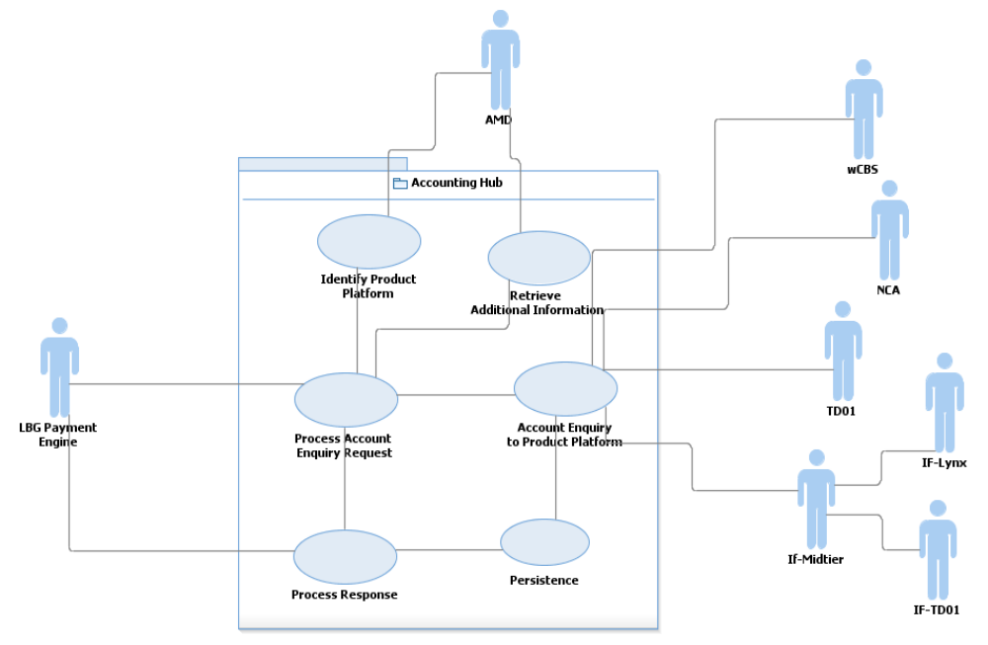
Figure 1: Account Enquiry Use Case Model

Actor Analysis
Sl No. | Actor | Classification | Stereotype | Actor Description
 | LBG Payment Engine | Sub System | Service Consumer | Will send the Account Enquiry request to Accounting Hub. Will send Sort Code + Account Number in its request message.
 | AMD | Sub System | Reference Data Provider | AMD will provide the following information to Accounting Hub for enquiry request.  1.Platform Id to which the account belong to  2. Availability of the product platform.  3. Additional Account Information(Ex. HOCA account details )  3. NPA account details
 | wCBS (Wholesale Core Banking System) | Sub system | Product Platform | wCBS is the HBOS Product Platform.
 | NCA | Sub system | Product Platform | NCA is the HBOS Product Platform.
 | TD01 | Sub system | Product Platform | TD01 is the HBOS Product Platform.
 | IF-TD01 | Sub system | Product Platform | IF-TD01 is the HBOS Product Platform.
 | IF-Lynx | Sub system | Product Platform | IF-Lynx is the HBOS Product Platform.

Use Cases
Sl No. | Use Case | Use Case Description
 | Process Enquiry Request | This is the main use case which processes the Account Enquiry request from LBG Payment Engine/Channel, orchestrates across the various major tasks of validation, enrichment, and enquiry.  This use case identifies the type of the request and handles the request as per the business logic.  This use case interacts with IdentifyProductPlatform use case to get product platform Id. It gets the meta data information about the platform in terms of its availability and additional Account information such as HOCA, collection account details etc. from AMD by invoking RetriveAddtionalAccountInformation use case.
 | IdentifyProductPlatform | This use case interacts with AMD to get the identity of product platform to which account belongs to. The use case will transform the request to that AMD format and invokes AMD over https.
- 3 | RetreiveAdditionalAccount Information | This use case interacts with AMD to get additional account information such as HOCA account details, collection account details in case of corporate/commercial customers etc. The use case will also retrieve meta data information of the product platforms.
- 4 | AccountEnquiryToProcutPlatform | This use case interacts with all HBOS platforms depending on the platform identified for the account. It will transform the Accounting Hub request to format of respective product platform. Hence in this case, it will treat it as an exception as no response received from product platform / enquiry not supported for the product platform and respond to the consumer.
- 5 | Process Response | Will receive the response from HBOS platforms, do necessary transformations before sending it back to LBG Payment engine.. Will also handle error code conversions from HBOS product platforms to Accounting Hub error codes.
- 6 | Persistence | This is the only use case which interacts with Account Hub data store. It is responsible for storing accounting hub related information in the database. It stores the group information, response related information, status of request & response messages etc.
Table 3:Use Cases List

Service Interfaces – Account Enquiry
Interface | From | To | Purpose | Format | Transmission
ProcessEnquiryRequest | LBG Payment Engine | Accounting Hub | Send Enquiry Request to Accounting Hub | IFW | MQ
ProcessEnquiryResponse | Accounting Hub | LBG Payment Engine | Send consolidated response (Account Balance & Status )to LBG Payment Engine | IFW | MQ
getAccountInformation | Accounting Hub | AMD | Send and receive account enquiry to AMD. | SOAP | https

Account Posting

Use Case – Account Posting

Model
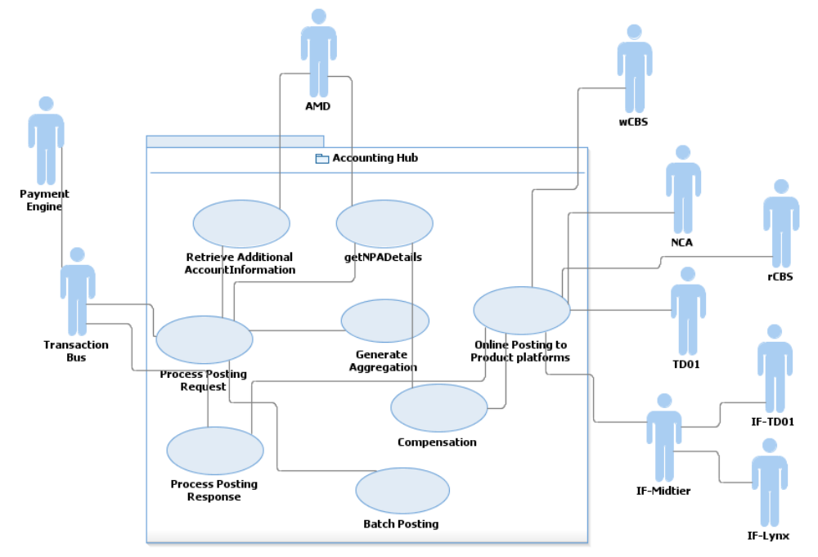

Actor Analysis
Sl No. | Actor | Classification | Stereotype | Actor Description
1 | LBG Payment Engine | Sub System | Service Consumer | Will send the Account Posting request to Transaction Bus..
2 | Transaction Bus | Sub System | Service  Consumer | Transaction bus (FTM) will send the Posting request to Accounting Hub. The message will be transformed to IFW format and will be wrapped in a SOAP envelop. Accounting Hub will generate the actual posting entries and pass to the product platforms. Accounting Hub responds with a response message based on the IFW schema and wrapped in a SOAP envelop
3 | AMD | Sub System | Reference Data Provider | AMD will provide the following information to Accounting Hub for posting request.  1.Platform Id to which the account belong to  2. Availability of the product platform.  3. Additional Account Information(Ex. HOCA account details )  4. Sequence of entries to be passed to a product platform  5. Posting Mode (online/batch)  6. Posting Type (Single/Aggregated)  7. Compensation entries  There will be two different service calls(getAccountInformation, getNPADetails) from Accounting Hub to AMD to retrieve the above information.
4 | wCBS (Wholesale Core Banking System) | Sub system | Product Platform | wCBS is the HBOS Product Platforms to which account postings will be done. It supports both online and file posting.
5 | NCA | Sub system | Product Platform | NCA is the HBOS Product Platforms to which account postings will be done. It supports file posting.
6 | TD01 | Sub system | Product Platform | TD01 is the HBOS Product Platforms to which account postings will be done. It supports both online and file posting.
7 | IF-TD01 | Sub system | Product Platform | IF-TD01 is the HBOS Product Platforms to which account postings will be done. It supports both online and file posting.
8 | IF-Lynx | Sub system | Product Platform | IF-Lynx is the HBOS Product Platforms to which account postings will be done. It supports both online and file posting. Accounting Hub will send the posting entries to IF-Midtier which in turn will post to this platform.

Use Cases
Sl No. | Use Case | Use Case Description
1 | Process Enquiry Request | This is the main use case which processes the Account posting request from LBG Payment Engine, orchestrates across the various major tasks of validation, enrichment, and enquiry.  This use case identifies the type of the request and handles the request as per the business logic.  This use case interacts with AMD to get product platform Id. It gets the meta data information about the platform in terms of its availability and additional Account information such as HOCA, collection account details etc. from AMD by invoking RetriveAddtionalAccountInformation use case. The use case will invoke getNPADetails use case to receive the required information for posting to HBOS platforms.
2 | RetreiveAdditionalAccount Information | This use case interacts with AMD to get additional account information such as HOCA account details, collection account details in case of corporate/commercial customers etc. The use case will also retrieve meta data information of the product platforms.
3 | getNPADetails | This use case is responsible for interacting with AMD to get the following information  Posting Mode (online/batch)  Posting Type (Single/Aggregated)  Sequence of entries to be passed to a product platform  Compensation entries  Collection Account details
4 | GenerateAggregations | This use case creates aggregation entries of Account posting. The aggregation of posting entries will be done based on the response from getNPADetails call to AMD. AMD will send whether aggregation needs to be done or not in ‘Posting Type’ field.
5 | Compensation | This use case creates compensation entries in case multiple steps involved in the execution and there is a failure in postings to HBOS product platforms.
6. | OnslinePostingToProductPlatform | This use case will post the online postings to product platforms. The use case is responsible for converting the posting request into platform required (native) format. It will use MQ as the transport protocol for connection from Accounting Hub to product platforms.
7 | BatchPosting | The use case will handle batch/file postings to product platforms. Accounting hub will consolidate the entries for each group w.r.t product platform and send to the Transaction Bus.The Batch posting component of Transaction Bus will be triggered at a particular interval either by a scheduler or by a control message, get all these entries from the database, create file or batch and post to respective product platforms. The control message from Accounting Hub is based on a schedule.
8 | Post Transaction Audit | This use case is responsible for posting audit information to TODS. It will send the audit information of each of transactions received by Accounting Hub.
9 | ProcessPostingResponse | This use receives the posting responses from product platforms. It will convert the product platform specific format into IFW format and sends the response back to Transaction Bus. In case of any exceptions, It will convert platform specific error codes into Accounting Hub error code and pass it to Transaction Bus.
Table 4:Use Cases List

Service Interfaces – Account postings
Interface | From | To | Purpose | Format | Transmission
ProcessPostingRequest | TMH | Accounting Hub | Send Posting Request to Accounting Hub | IFW | MQ
ProcessPostingResponse | Accounting Hub | TMH | Send posting response to TMG | IFW | MQ
getAccountInformation | Accounting Hub | AMD | Send and receive account information from AMD. | SOAP | https
getNPADetails | Accounting Hub | AMD | Receive NPA/ settlement/ contra information | SOAP | https
AccountPostingTorwCBS | Accounting Hub | wCBS | Send Account Posting to wrCBS | SOAP | MQ
AccountPostingToNCA | Accounting Hub | NCA | Send Account posting to NCA. | SOAP | MQ
AccountPostingToTD01 | Accounting Hub | TD01 | Send Account postings to TD01. | Fixed width | MQ
AccountPostingToIFTD01 | Accounting Hub | IFTD01 | Send Account Postings to IFTD01 via IFMidtier | SOAP | MQ
AccountPostingToIFLynx | Accounting Hub | IFLynx | Send Account Postings to IFLynx via IFMidtier. | SOAP | MQ
AccountPostingToNCA | Accounting Hub | NCA | Send Account Postings to NCA. | SOAP | MQ

Service Interfaces – Posting Mode
From | To | Posting Mode | Description
Accounting Hub | wCBS | Online & File/Batch | Posting entries for customer accounts on wCBS for all payment schemes
Accounting Hub | NCA | Online & File/Batch  (For example CHAPS will be a MQ message, while for international it will be files) | Posting entries for customer accounts on NCA and settlement entries  The file bulking functionality will be delivered by Transaction Bus.
Accounting Hub | TD01 | Online & File/Batch | Posting entries for customer accounts on TD01 for all payment schemes
Accounting Hub | IFTD01 | Online & File/Batch | Posting entries for customer accounts on IF-TD01 for all payment schemes.  Send the message to IF-Midtier, and IF-Midtier forwards to IF-TD01 Reuse the functionality as it exists today
Accounting Hub | IF-Lynx | Online & File/Batch | Posting entries for customer accounts on IF-Lynx for all payment schemes.  Accounting Hub will route to IF-Midtier, and IF-Midtier forwards it to the IF Platforms  Reuse the functionality as it exists today
Accounting Hub | rCBS | Online | Settlement entries for customer postings for all payment schemes. This can be both individual contra postings or aggregated contra postings

Traceability
Refer to “Accounting Hub Traceability Matrix” Use case, Components and Solution traceability items.

Accounting Hub Platform Enhancement

Accounting Hub framework has been built now with three major business services hosted on top of a loosely-coupled, SOA based framework. The current framework has the ability to add product platform posting maps extended from a generic posting or enquiry controller.
Considering the situation of constant changes, progressive building of capabilities, frequent changes to fundamental service functions (until the functions mature into stable state within payments IT landscape), plug-n-play mode of adding new interfaces to product platforms, phased on boarding of payment types, there is an opportunity to enhance the platform to an adaptable framework making it capable of participating in continuous integration delivery cycle. The enhanced platform will be more resilient, adaptable and extensible in a progressive manner. This is at the back drop of a must do design change for IT Resilience requirement of multiple platforms posting (Account posting).
IT Resilience enabler project is identified as an opportunity to enhance and re-align the underlying framework for Accounting Hub. The existing functionalities will remain as-is. However its implementation of services & components will be tailored to suit the MicroKernel pattern explained here. To understand more about Microkernel pattern and relevance to Accounting Hub refer to the document specified in Section 1.6 section.

Accounting Hub – State models based on Microkernel pattern
The core principle on which Microkernel pattern (and many other loosely coupled dynamic processing models) is built is to be able to work on top of a state machine that is configurable. The current design of Accounting Hub is an application of deterministic finite state model – FSM.
A finite-state machine (FSM) or finite-state automaton (plural: automata), or simply a state machine, is a mathematical model of computation used to design both computer programs and sequential logic circuits. It is conceived as an abstract machine that can be in one of a finite number of states. The machine is in only one state at a time; the state it is in at any given time is called the current state. It can change from one state to another when initiated by a triggering event or condition; this is called a transition. A particular FSM is defined by a list of its states, and the triggering condition for each transition. Reference: http://en.wikipedia.org/wiki/Finite-state_machine
- State transition table or event table is used to hold definition of states. The core state model is configured in the tables / DB to be picked up dynamically by core state machines and acted upon.
- The design for Accounting Hub should cater for
  - Pre-configured state transitions (e.g. flow of events after receiving requests, validation, etc)
  - Dynamic state transitions (e.g. posting sequence obtained from AMD response, etc.)
  - Ability to over-ride dynamic transition and force a particular sequence of events (e.g CBS posting should always be parallel or sequence, etc.)
- Here is a simple diagram representation of state machine for Accounting Hub. It is a deterministic state model with a single overarching state both as accepting and final state.
Accounting Hub
- For Accounting Hub, Flow controller and Map Router are the two major state machines to solve the many types of processing possible through the hub.
- Flow controller will be the first and last major element that will be called multiple times during the course of a transaction processing and flow controller may call the same or different functions to achieve the state transition at each of the instances. The diagram below will provide an indication of how it will implemented.
State A
State B
Function F1, F2, Fn, ..
State B
State C
Map M1, M2, Mn, ..
Flow Controller
Map Router
Following are the unique set of FSM (models) identified for implementing various functions on top of Accounting Hub. The overarching design of any services or requirements withing Accounting Hub will be a combination of one or more of these pre-defined FSM / models explained below.

Synchronous request-response model
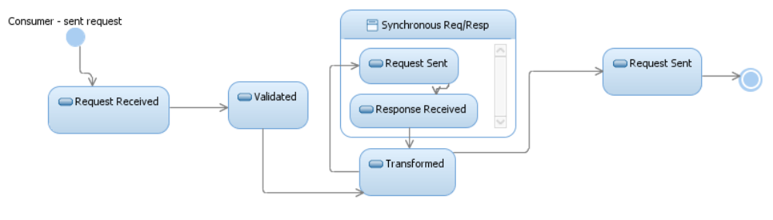
This is model represents a simple flow of transaction involving Accounting Hub calling an endpoint using synchronous mode like HTTP. E.g. Request received for AIS, validated, transformed and AMD getAccountInformation called to fetch additional static account details and platform meta-data.

Asynchronous request model
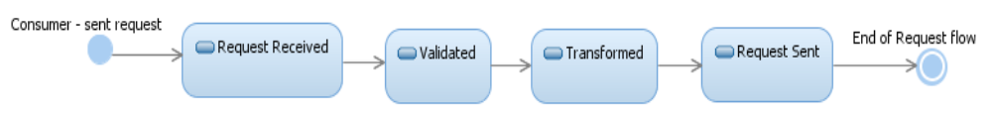
This is model represents a very simple flow of transaction involving Accounting Hub calling an endpoint using asynchronous mode like WMQ. E.g. Response received back from AMD, validated, transformed and request sent to product platform for real-time balance and account status.

Asynchronous response model
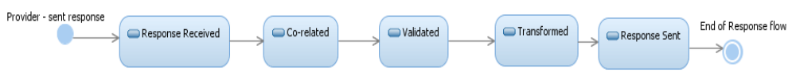
This is model shows a very simple flow of transaction involving Accounting Hub receiving a response from endpoint using asynchronous mode like WMQ. E.g. Response received back from CBS, co-orelated, validated, transformed and final response sent back to TMH as IFW response.

Group Control – Fan-out model
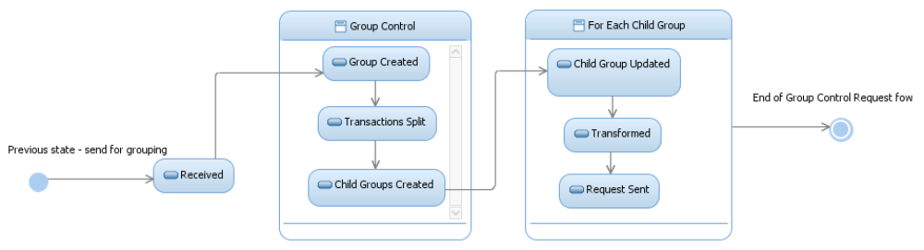
This is slightly complex model (famously known as fan-out in EAI patterns) of transactions through Accounting Hub that require grouping -splitting or branching of flows into multiple parts. E.g. AMD returns posting information to APS, APS has to post account entries into multiple product platforms in parallel, receive response from all together and then send back IFW response for original APS request from consumer.

Group Control – Fan-in model
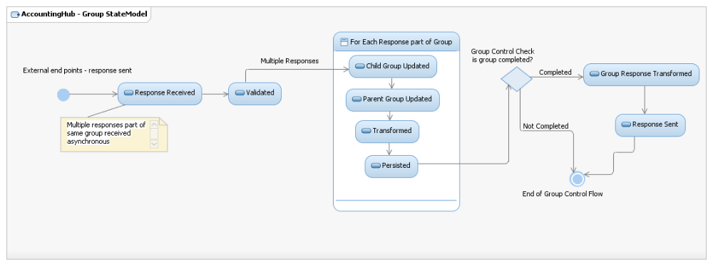
This model (famously known as fan-in in EAI patterns) is complimentary of the previous model where in responses are received asynchronously from end points for each of the child part of a parent group. E.g. CBS, Common and wCBS all send back posting response in parallel and asynchronously back to Accounting Hub which form part of the same posting group. The individual responses are collected over multiple threads / instances and child group updated. Group control check will ensure completion of group and triggering of the next state of response transformation and sent back to original consumer.

State Model Design Elements
The following section details the design elements that complement the state models explained.
- Typical flow of a transaction through accounting hub will be like below:
Consumer → (Interface Handler + Interface Adapter) → Flow Controller** → Process N → Map Router** → Interface Map N → Interface Adapter → External Destination
The key point to consider is – flow controller called multiple times according to configured state transition; map router called multiple times accordingly to number of interface maps required to be called for transformation.
- State / Event table: Popular method of storing states and the transition details is using a State or Event table. The combination of current state (e.g. B) and input (e.g. Y) shows the next state (e.g. C). A FSM definition including the full actions information is possible using state tables. Following this approach, Accounting Hub will have a new table introduced to hold states, expected transition route, destination, etc. The blueprint of the table TFC_FLOW_CONTROL is given below:
Flow_Id | Service_Id | Current_State | Next_State | Routing_Destination | Destination_Dtls | Process_Mode
1 | AIS | Received | Validated | ACH_Validation_SF | Sub-flow | Seq
2 | AIS | Validated | getAccInf Requested | ACH_MAP_AMD_REQ | MAP_ROUTER_IN | Seq

- Policy table: Policy details are the additional meta-data required for identify and processing a typical message type, e.g Account Enquiry for Common, Account posting for CBs, etc. Policy table will hold information like service details, known transition states, external parameters, etc. The detailed design will make final decision of whether to combine policy and state transition together and store in same table.
- Both the Policy details and Flow control information are candidates for caching. Current WMB caching mechanism used within Accounting Hub will be enhanced (or reused) to store details into the cache whenever flows are stared afresh.
- Canonical control headers: The cached information is used to retrieve and identify against each of the incoming request. The meta data of transaction is matched up against stored meta data to identify the right set of policy details and flow control applicable. This could be coded into the Interface handler part. Once retrieved, the details are mapped into a simple and light-weigth canonical control header that will be passed along the complete chain of subsequent flows to avoid multiple DB / Cache retrieval.
- The implementation of state machines has to be node agnostic. The deployed instance of main flow (e.g flow controller) shoud be able to process or pick up from any particular state and transition to any other state irrespective of the previous state transition event processed in a different node. E.g. Flow controller deployed in Broker B should proceed to pick a transaction from state B and progress to state C even if A → B was performed by flow controller deployed in Broker A.
- Node agnostic implementation of state transition enables recovery of transactions when they are failed or delayed or stuck in a specific state. E.g. when the Broker A is terminate or shut down after posting a message to CBS, the response should be processed successfully through the next available node of Broker B.
- Leader Election algorithm: Detailed design has to check the feasibility of utilizing “leader election algorithm” generally used in distribute programming to achieve concurercy and task delegation between simlar nodes. The underlying principle is to come up with a mechanism of choosing the fail-back or stand-by node / broker which will progress the transaction life cycle further and complete it. To begin with, it could be a simple priority list and circular dependency setup between multiple brokers, considering the limitation within WMB broker setup. Note: The idea should be generic enough to consider any number of nodes / brokers – 2, 4, 6, etc.
- There are two aspects of failures and options to recover (explained in detail section 4.5)
  - Broker Infrastructure setup: At implementation level, the failures and fall back could be handled by utilizing and implementing WMB “Multi-instance broker” setup. This setup will have active-passive broker pairs for each of the brokers and fail-over is automatic (with some scripts involved by Infrastructure administration).
  - Flow-level failures: This is better handled within application by introducing a timer-controlled WMB flow that’ll look up for transactions that aren’t moved into next expected state within a time-out window or combination of exceptions or other IT failures. Once chosen, the transaction will be restarted from it’s current state and progressed in any of the other stand-by broker node by dropping payload into right WMQ Queues. The payload of various states have to be stored in the DB for this.
E.g. When Broker A is terminated after posting a request to CBS for a transaction (APS Request), recovery flow will understand the failed state and force the response from CBS into Broker B for futher processing.
- Other Key design considertaions: Here are few other key design considerations to be followed up in detail.
  - Time-out: Time-out parameter should be considered to be part of individual states for better granularity and control. E.g. posting CBS could be both sequential and parallel and also one of them could require time-out while the other may not need it.
  - Throttling: Throttling limit or threshold should be a configurable value associated within a state to allow multiple levels of throttling to next states. E.g. posting to Common may require throttling of messages in bunch of 50 per second, etc.

Accounting Hub – Component Model
The following diagram depicts at a high level the different components that are identified to be part of Accounting Hub framework based on MicroKernel Pattern.
- MicroHub is the central thin layer that represents micro kernel. This is the minimalistic set of components required to deliver and execute services hosted on Accounting Hub.
- Adapters are collection of components managing physical connections to external end points.
- Interface maps are the primary components that may undergo changes based on business requirements, platform API changes and accounting model.
- All ther other components are called or used accordingly and generally provide extensibility and can be progressively built as per requirements.
- Implementation of any services or future requirements on top of Accounting Hub will eventually consist of steps as below
  - New interface handler for each distinct services
  - Policy & Flow control (states) configuration for message routing and transformation
  - New or reused Interface maps
  - Depending on requirements, new business functions may be added to enhance core functionality of MicroHub based on exposed interface for the corresponding servers, e.g. Aggregation.
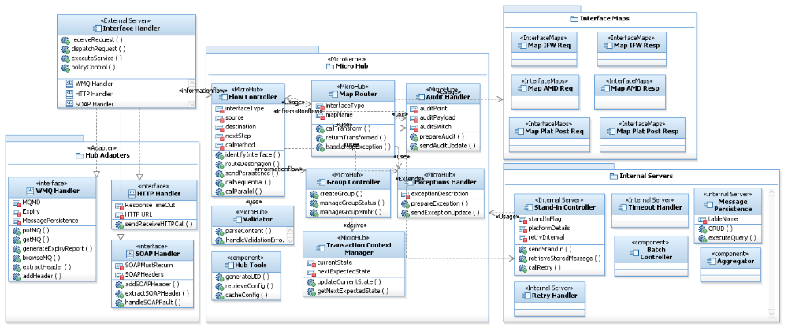

- Interface Handler – This will serve as external servers, managing interfacing with external end points from outside of AHUB platform. This could be both send and receive requests on either side of the flow processing through AHUB (e.g. IFW, AMD, CBS, COMMON, etc.). Depending on requirements, a new instance of Interface handler could be derived out of interface handler template to provide service specific functions – e.g. AIS Interface, APS interface, etc.

- Hub Adapters – Encapsulate and hide all physical communication related aspects and provide core functions for message send and receive – WMQ handler, HTTP handler, SOAP handler. These core functions will be used by Interface handler

- Micro Hub – The central microkernel pattern for hub. This will be primarily a collection of frequently used functions that frame the core of the hub. Both Interface handler and Flow controller/ Map Router will use many functions provided by Micro Hub components. These form the minimal set of components required to host the Accounting Hub platform providing basic set of processing required for an online service hosting – validate, route, persist, audit, exceptions, group control, transaction context management, etc.

- Flow Controller – The central intelligence function that’ll orchestrate between multiple flows and components. The sequence of processing for a request / response flow is split into multiple events that drive each other by calling next step in flow-agnostic mode. This flow of events is controlled by Flow controller. This is an internal server deployment of Microkernel pattern. Note: The Flow controller should be able to control the next processing steps in parallel or sequence depending upon configuration.

- Map Router – Map Router is another internal server extending one or many core MicroHub functions to identify interface type, match online information with cached flow details and call relevant maps for transformation.

- Interface Maps – these are extendable and independent components developed for each of the interfaces and contain mapping rules. Modifying mapping rules based on interface requirements should not impact overall deployment of flows and control of events. These are the key components aiding in adaptable and extensible platform. Any new interface or end point will require creation of multiple maps and not modify any of the other core components thus reducing build time.

- Policy configuration – this is a critical portion of the implementation. The policies could be
  - External service policies – one or more policies per consumer or per service calls, e.g. SOC enquiry, GPP enquiry could have separate set of policies on top of group of policies setup for enquiry and posting.
  - Internal flow control policies – internal policies determine the routing of flows by identifying next process steps, sequential or parallel, end-point URL, adapter type, etc.
  - Finally, the polices are stored and retrieved using cache (shared row variables) for MB flows to access them, reducing DB read/write

- State / Event table – this is another critical portion of the implementation. The internal flow control policies are defined as states or events to enable dynamic flow routing.
  - Individual states are stored along with state boundary, state entry criteria, current and next state transition, default modes, etc.

Accounting Hub – Component Realisation
The following table explains at a high level the different FSM (state models), transition of states and components proposed to realize the transition of states (actions).
State Model (FSM) | Sequence  of Steps | State Name | Entry Condition | Action | Components | Component Type
3.1.1 Synch Req-Resp | 1 | Request Received | External endpoint sent service request | Receive message | WMQ Handler  Interface Handler | Sub-flows  Main flow
3.1.1 Synch Req-Resp | 2 | Validated | Succesful receipt of message | Validation routine | Flowcontroller  Validation | Sub-flows
3.1.1 Synch Req-Resp | 3 | Transformed | Successful validation | Transform format to AMD request | MapRouter  AMDRequest Map | Main flow  Sub-flows
3.1.1 Synch Req-Resp | 4 | Request Sent | Successful transformation | Send HTTP Request to AMD | Flowcontroller  HTTP Handler | Sub-flows
3.1.1 Synch Req-Resp | 5 | Response Received | Valid response from WS call | Receive HTTP Response | Flowcontroller  HTTP Handler | Sub-flows
3.1.1 Synch Req-Resp | 6 | Transformed | WS call succesful | Transform AMD response to Platfrom format for enquiry / posting | MapRouter  CBSRequest Map | Main flow  Sub-flows
3.1.1 Synch Req-Resp | 7 | Request Sent | Successful transformation | Send WMQ Put request to CBS | Flowcontroller  WMQ Handler | Sub-flows
3.1.2 ASynch Request | 1 | Request Received | External endpoint sent service request | Receive message | WMQ Handler  Interface Handler | Sub-flows  Main flow
3.1.2 ASynch Request | 2 | Validated | Succesful receipt of message | Validation routine | Flowcontroller  Validation | Sub-flows
3.1.2 ASynch Request | 3 | Transformed | Successful validation | Transform format to AMD request | MapRouter  AMDRequest Map | Main flow  Sub-flows
3.1.2 ASynch Request | 4 | Request Sent | Successful transformation | Send WMQ Put request to CBS | Flowcontroller  WMQ Handler | Sub-flows
3.1.3 ASynch Response | 1 | Response Received | External endpoint sent service response back to AHUB | Receive message | WMQ Handler  Interface Handler | Sub-flows  Main flow
3.1.3 ASynch Response | 2 | Co-related | Succesful receipt of message | Co-relation with original request | Flowcontroller  TCM | Sub-flows
3.1.3 ASynch Response | 3 | Validated | Successful match of req-resp | Validation routine | Flowcontroller  Validation | Sub-flows
3.1.3 ASynch Response | 4 | Transformed | Successful validation | Transform format to AMD request | MapRouter  AMDRequest Map | Main flow  Sub-flows
3.1.3 ASynch Response | 5 | Request Sent | Successful transformation | Send WMQ Put request to CBS | Flowcontroller  WMQ Handler | Sub-flows

Accounting Hub – Block Architecture
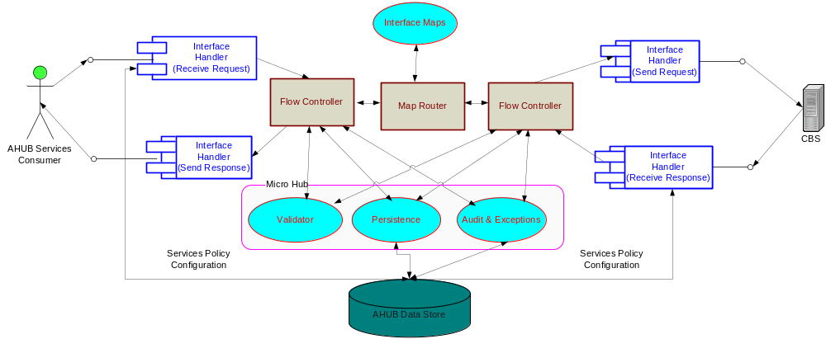
- All three services hosted within AHUB will have no specific flows (except for possibly customized interface handlers per service implementation) but built upon set of commonly reused flows. Actually there will be no distinction between different services. The components will serve agnostic of service types
- However, with help of policy configuration, it should be possible to turn on and off all the services independent of each other.
- Both request and response flows will follow a similar pattern – receive, flow controller, validate, persist, audit & exceptions, map router, send to end-points.
- Policies configured will drive the flow of events between individual components
- The number of processing steps, sequence or parallel execution modes and other flow processing requirements are available in WMB broker cached area for online flows to utilize and act upon.
- What should be the next step after completing a single processing step is picked up dynamically from the configuration and matched with interface type / online information.
- After completion of a processing step, the control of execution returns to flow controller which will call the next step or component.
- Interface handler will serve like mirrored entry points to AHUB – both receive and send.
- The flows are agnostic of the number of end points connected to AHUB and direction of flow (request, response, outbound, etc.). Interface handler will effectively come in at both ends of a processing step.
- Interface maps are called according to various external end points and interfaces being linked in processing of a flow (service implementation).
- Refer to the Information architecture for high level design of policy details and entities.

Accounting Hub – Services Realisation
This section describes on how services are realized within Accounting Hub platform. Accounting Posting to CBS is taken up as an example to explain the sequence of interactions between various components.
The first sequence diagram explains the flow of control and information across various Microkernel based components in a generic way.
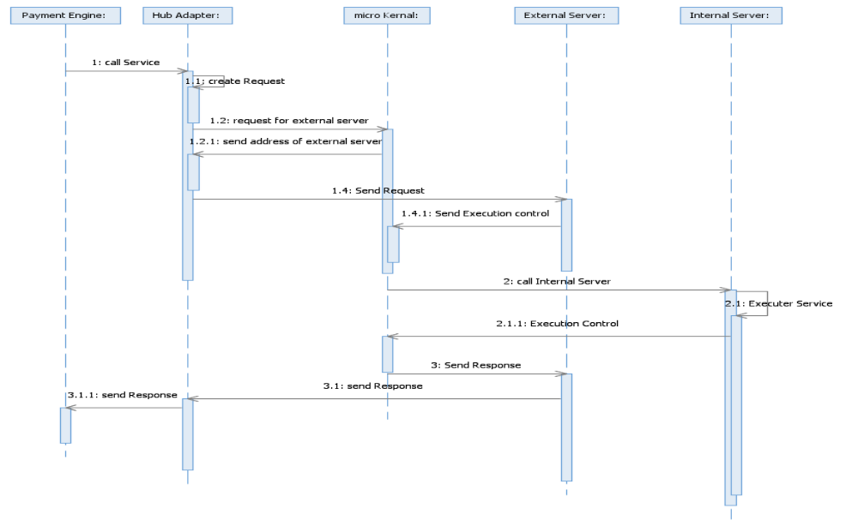
The second sequence diagram is a drilled down level and explains the flow of control and information as it happens by applying Microkernel within Accounting Hub.
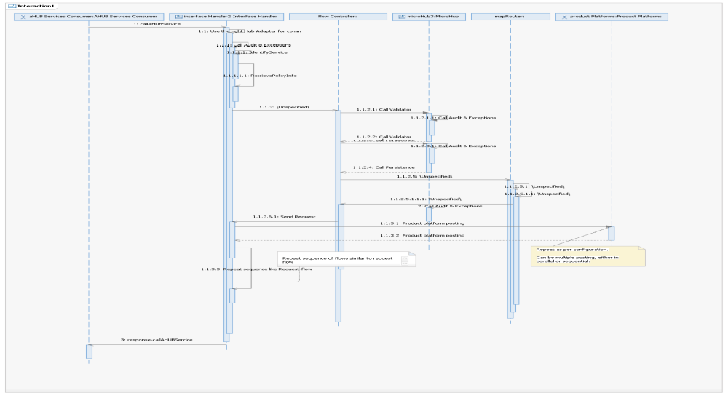
- Interface handler receives the requests from external consumers into Acocunting Hub. This becomes the first entry point for Accounting Hub.
- The right set of hub adapters are used to receive the transmitted request (e.g. WMQ handler).
- Interface handler should log the messages, identify service type based on incoming message parts compared against cached configuration details.Retrieve entire policy set based on identified entities.
- The transaction is then passed on to the flow controller to orchestrate the main processing.
- Flow controller should utilize a combination of cached configuration, previously identified details (passed through MQMD, MQRFH2 and AHUB internal control headers). Possible steps of processing could follow the below sequence.
- The first step could be calling validator function to check structural and business validity of the request message content.
- The next step is to call AMD with getAccountInformation request. To achieve this, the transaction control is passed on to MapRouter which dynamically decides the right map to be called for transforming request message into AMD request format.
- Transformed message is audited, transaction context updated accordingly and AMD request is sent to AMD using HTTP handler (hub adapter).
- Since AMD has been designed as online HTTP call, the response is received back to a specific AMD receive flow and control passed back to flow controller which determines the next step. There could be multiple legs of posting requirement based on accounting model configured within AMD.
- Similar steps of flow control – map router – transformation – hub adapter are repeated for the number of times posting has to be branched out (AMD response – multiple platforms posting).
- Flow controller manages the mode of posting and sequence of posting, again based on configuration.
- The final step called by flow controller eventually calls the IFW response map that collates the transaction / posting details and send back to consumer using right set of adapters (WMQ handler for TMH).

Accounting Hub – State Transition
This section highlights the complete transaction life cycle and transition of states through accounting hub service flows.
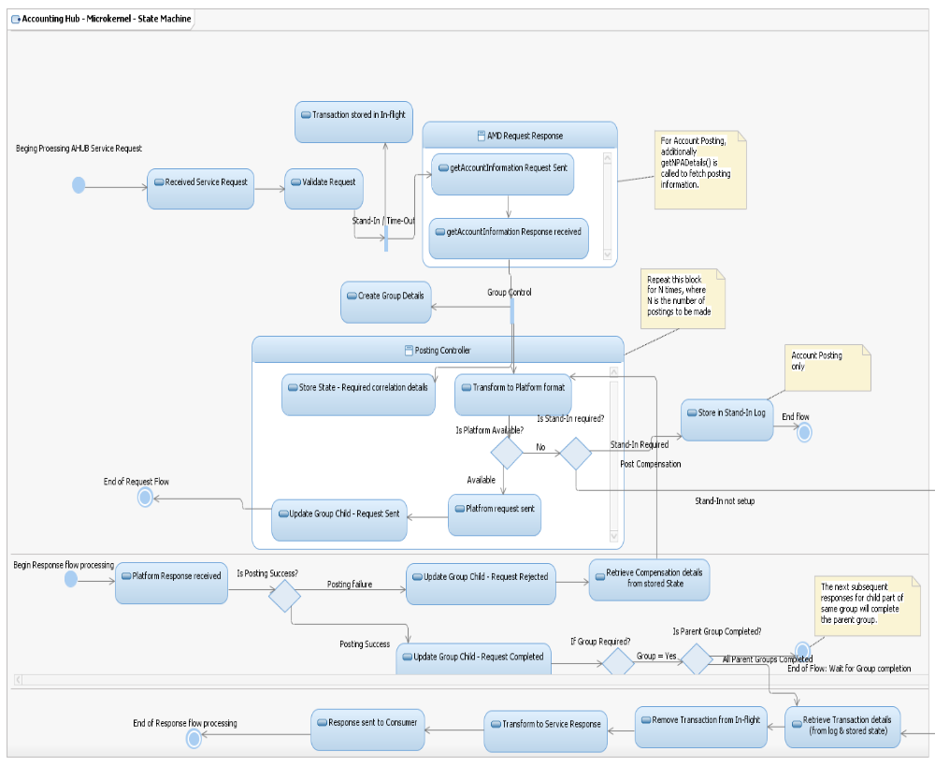

Microkernel – Design limitations
There are few known limitations that should be considered and worked around during detailed design when Microkernel is being implemented for Accounting Hub within WMB product set.
- From an operations management perspective, tracking a transaction will now have additional states and steps to be looked into. But the advantage is for any transaction to follow a standard model and once the model is familiarized it’ll become easier and standard.
- Since the transactions are broken down into multiple legs than a normal WMB approach is applied, the complete roll back of a transaction has to be managed additionally within Application. Otherwise, the choice is to accept the transaction into various states, hence the failures are restricted strictly down to each of the states and transition.
- In the unlikely event (or less progbable) of any changes to Micro Hub – micro kernel components like Flow Controller and Map Router will require additional test effort for regression as all the AHUB services will be impacted directly. The mitigation will be to fool-proof the detailed design to include as much generic functions as possible and do it right first time.

Design

System Context Diagram
Refer to “Accounting Hub E2EPD” (Section 2.2 – Context Diagram)

Architecture Overview
Refer to “Accounting Hub E2EPD” (Section 6)

Account Enquiry

AIS Processing steps - Activity Diagram

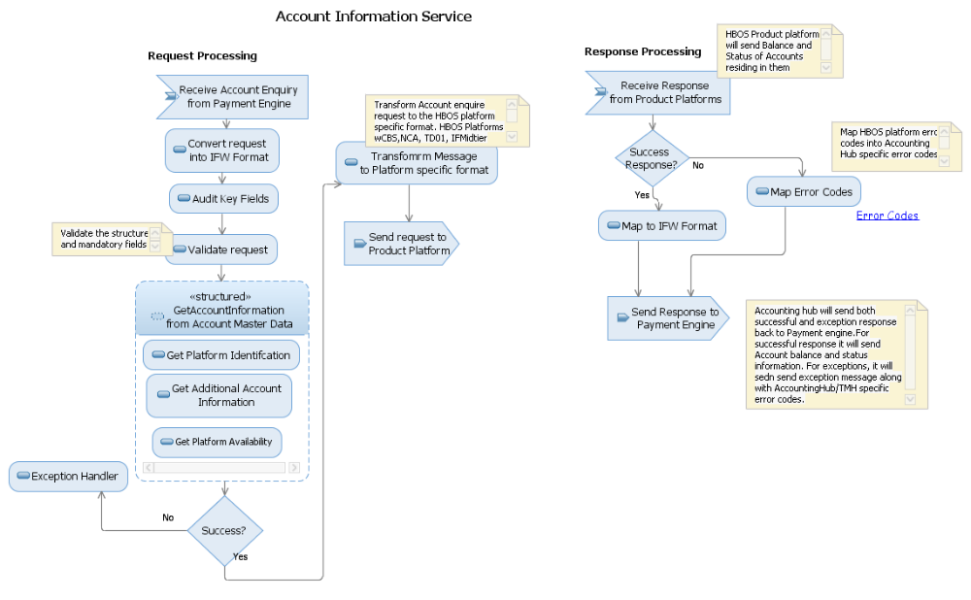
- Payment Engine will send Account Enquiry request to Accounting Hub over MQ.
- Accounting Hub will transform the request into into IFW format.
- Accounting Hub will validate the request both for correct structure and mandatory fields like Account number and sort code etc...

- Accounting Hub transform the request to Account Master Data format and invoke it to get
  - product platform identification of the HBOS platforms (wCBS,NCA, TD01 & IFMidtier )to which the customer account belong to
  - Additional Account information of the account.
  - Availability of the product platform.
- Once the Platform id is known, Accounting Hub will transform the request into the platform specific format and send the request to it..
- In case of any exception response from AMD, Accounting Hub will send appropriate exception message back to Payment engine.
- Product platform will send the account enquiry response containing Account Balance information, Account status to Accounting Hub..
- Accounting Hub will transform the response back to Payment Engine specific format and send to it over MQ.
- In case of any exceptions from HBOS Product platforms, Accounting Hub will send the exception back to Payment engine.
- While sending the exception message to Payment Engine, Accounting hub will convert the product platform error codes to Accounting Hub/TMH specific error codes as per the mapping sheet

AIS processing steps - Sequence Diagram

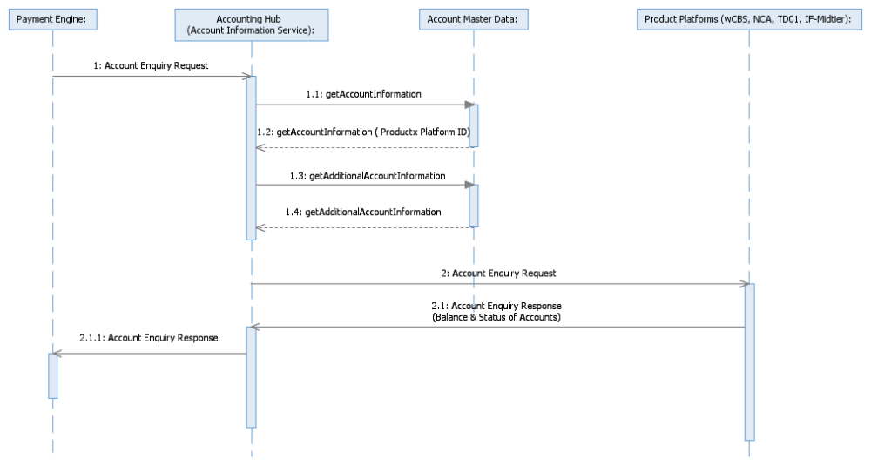

AIS Implementation model
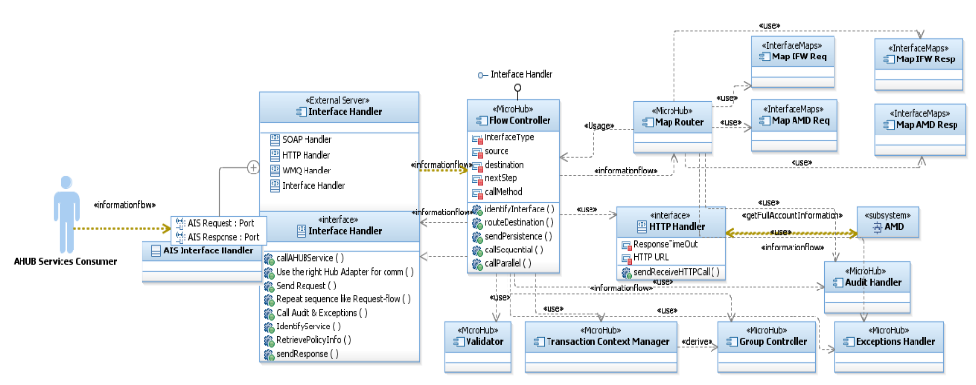
The diagram above depicts at a high level the implementation of Account Information service layered on top of Microkernel architecture.
Key highlights as below:
- AIS Interface handler is specific for AIS to cater for IFW request for AIS and also determine rules of processing specific to AIS.
- Once the related policies are fetched at interface handler level, the transaction is passed to flow controller for complete transaction management across components.
- MapRouter is called upon to determine necessary maps as and when processing step reaches various stages. The transaction context manager keeps track of the overall transaction status and also feed the group controller if required. Audit and expcetions are called as appropriate.
- For HBOS implementation, the IFW response is sent back immediately after receiving static account details from AMD.

Account Posting

APS Processing Steps - Activity Diagram
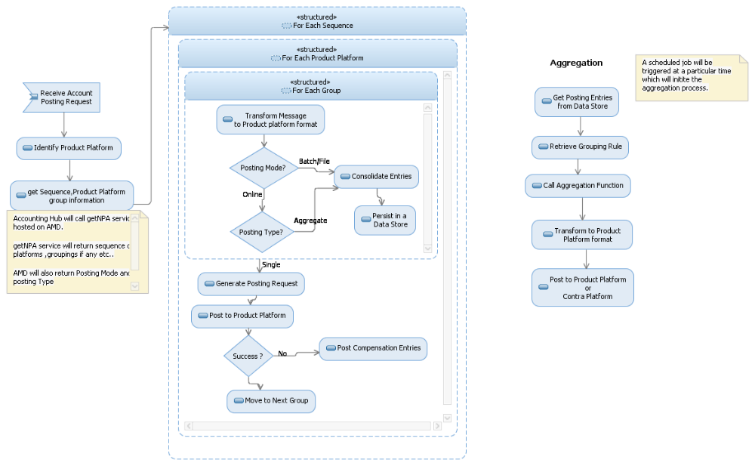
- Receive Account Posting request from Payment Engine/TMH.
- Identify the product platform to which the account belong, from Account Master Data
- Get Additional Account Information from AMD
- Get the meta data information of the product platform ( its Availability for posting etc)
- Get the following information from getNPADetails service hosted on AMD
  - Posting entries by Payment scenarios
  - Posting mode (file, online) for each of the entries
  - Posting type (single/end-day aggregated/ time-bound aggregation) for each of the entries
  - Entries to be grouped by Product Platform and posting sequence
  - Compensation entries if a posting fails
  - Collection account details
AMD will return the sequence of product platforms to which these posting have to be sent. Each of the platforms in sequence will have groups (like app group in rCBS) The postings have to be sent to all the groups in the product platform as per the AMD response.
- If the posting mode is file, accounting Hub will consolidate the postings and stores in a database. The Batch processing component will get triggered by a scheduler at certain time, will pick these entries from database, create the file from these postings and send to the product platform though connect/direct protocol.
- If the posting type is aggregated posting, then Accounting hub will consolidate all the postings to be aggregated based on AMD response and store in a database. The aggregation component will retrieve all these entries from the database and send to the product platform which is identified by AMD.
- For commercial/non-commercial customers, the postings will be done for the collection account returned by Account Master Data.
- If the posting is successful, send the success response back to Payment Engine by transforming it into PE format.
- For any exceptions, the product platform specific error codes will be converted to Accounting Hub error code and the exception response will be sent back to PE.
- Once a group posting is done for a particular platform, the posting will be done for the next group for the platform.
- Once all of the group posting are completed for a product platform, the postings will be done for the subsequent platform as per the sequence returned by AMD.
- If a particular product platform is not available, the messages will be stored in the database and replayed once the product platform is available as part of stand-in process.
Posting to wCBS: Accounting Hub will be posting all payments types to wCBS. It will build the interface with wCBS for file and MQ based postings.
Currently FPS postings to wCBS go via Message Switch .STP sends these postings in SPA format to message switch and then message switch posts to wCBS using AK350 format. Accounting Hub will use the same route as FPS for CHAPS postings to wCBS. Accounting Hub will send the SPA format posting request message(Online MQ message) to message switch for CHAPS payment types. Message switch then will post this to wCBS using AK350 format. For International/BACS/Clearings Accenting Hub will send the file in AKFM350 format directly to wCBS
Postings to IFTD01/IF Lynx : All postings to IFTD01/IFLynx go via IF-Midtier. Currently FPS postings to IF platform goes via Message switch .STP sends it in SPA format to message switch and then message switch post it to IF-Midtier. IF-Midtier separate out the postings for current/saving accounts and accordingly send it to IFTD01 or IFLynx. Accounting Hub will utilize the message switch route to post to IF platforms as an online MQ message for CHAPS payment postings. For International/BACS/Clearings AHUB will send the file to IF-Midtier.
Postings to TD01 : Accounting Hub will utilize the message switch route to post to TD01 platform as an online MQ message for CHAPS payment postings.
For International/BACS/Clearings AHUB will send the file to TD01.
Postings to NCA :NCA only accept postings in file format. For CHAPS/International/BACS/Clearings Accounting Hub will use Transaction Hub file processing solution. The file processing as delivered as part of this project is a low volume file solution. This will leverage the File bulking feature of Transaction Bus. This function will be delivered on all the instances of FTM
Note: The message switch route for CHAPS has to be confirmed by the IF/Message Switch SME’s. Only after the confirmation we can finalize this interface.
As per the initial discussions with SD team (Phil Cartwright), message switch can be used to post to wCBS, IFTD01/IFLynx, TD01 for CHAPS payment .To use the existing message names or new in message switch for these platforms will have to be confirmed by the message switch ADM support team. Please find the attached email regarding the same

APS Processing Steps – Sequence Diagram

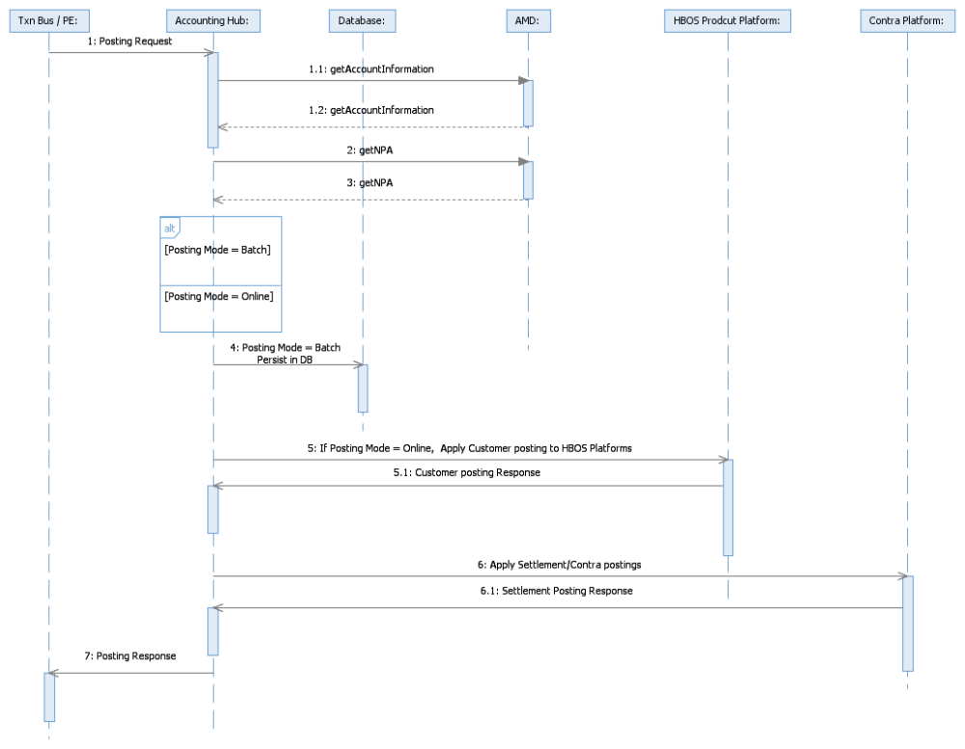

APS Implementation model
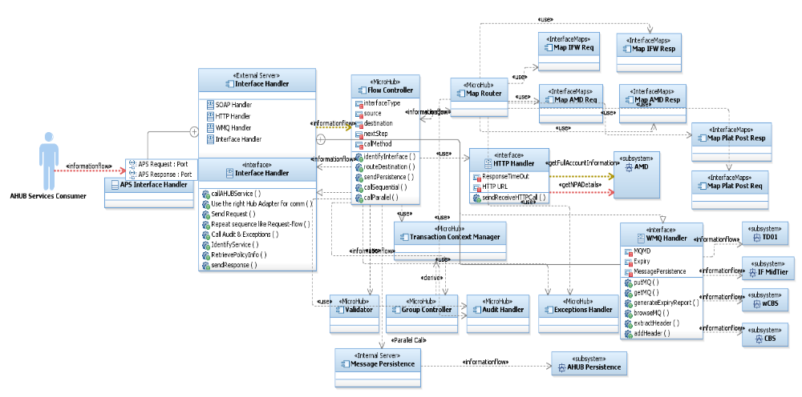
The diagram above depicts the high level component model or implementation of Account posting service layered on top of MicroKernel architecture.

Inter platform Posting

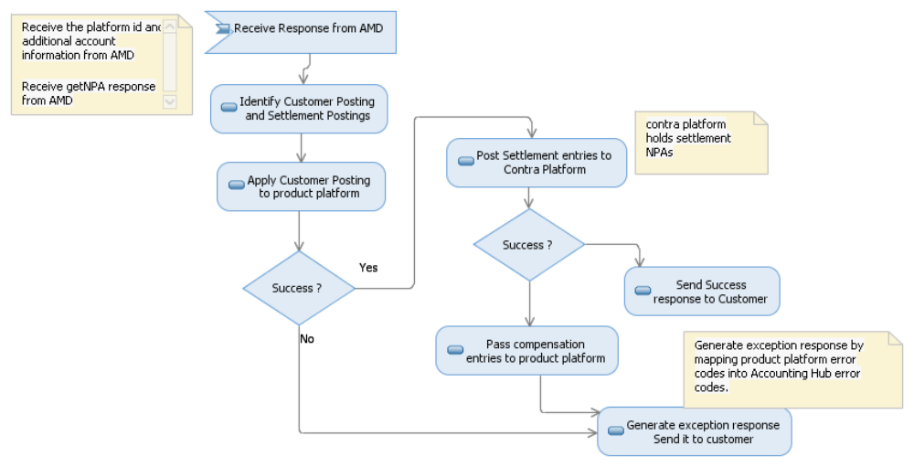

- Receive the posting request from Payment Engine and transform to IFW format.
- Identify the product platform by sending the request to AMD.
- Get the settlement, compensation entries from getNPADetails service hosted on AMD.
- Apply customer posting receive from Payment engine to the product platform identified in step 2
- If the posting mode is file, then the customer posting will be saved to the database and considered as success.
- If the posting mode is online, then wait for the response from product platform.
- If the customer posting is success, then the settlement entries will be applied to the contra platform. For ex. For FPS, rCBS is the settlement contra platform. Settlement contras can be aggregated or non-aggregated. The grouping of entries will be based on the reference data returned by AMD. These settlement entries can be sent as a file or online over MQ.
- If there is any failures in settlement contra posting, send the corresponding compensation entries to product platform.
- For any exceptions while posting to product platforms, an exception message will be generated and sent to customer. The error codes of the product platforms will be mapped to Accounting Hub error codes and transformed to Payment engine format before sending the exception message.

Batch Posting
- File generation capability in Transaction Bus will be used by Accounting hub for the current solution involving batch posting.
- Transaction bus will bulk the posting records generated by Accounting Hub. The file generation to product platforms will be triggered either based on a defined schedule or a control message from Accounting Hub.
- Accounting Hub will send posting entries to Transaction Bus. One of the available instances of Transaction Bus will read the message and parse the record. Once parsed successfully the record will be persisted to its local database.
- Batch posting from Accounting Hub perspective has been split up into three distinct flows / interfaces as explained below.
- AMD will be the key driver sending posting mode information to Accounting Hub which will be either online or batch. If batch, APS will call batch functions to generate new batch id and transform into platform format. Transformed data is sent online to Transaction bus for accepting into a batch.
- If the triggering of batch is from Accounting Hub, the send batch control interface will manage to trigger off set of batches that are due for completion. The trigger signal will drive for Transaction bus to complete the bulk process and send files to various product platforms.
- An offline batch status interface from Transaction bus to Accounting hub will be utilized in completing the batch posting process within Accounting hub closing out status of individual transactions part of a batch.
- Note:
  - The aggregated entries also may be sent as part of batch trigger message depending on accounting model and AMD reference data.
  - The batch control will have ability to send transformed header + trailer + aggregated data entries that will form the part of original batch it was assigned earlier. Transaction bus will have to bulk all these different transaction types together and send the files over.

Batch Posting – Interaction with Transaction Bus (FTM)
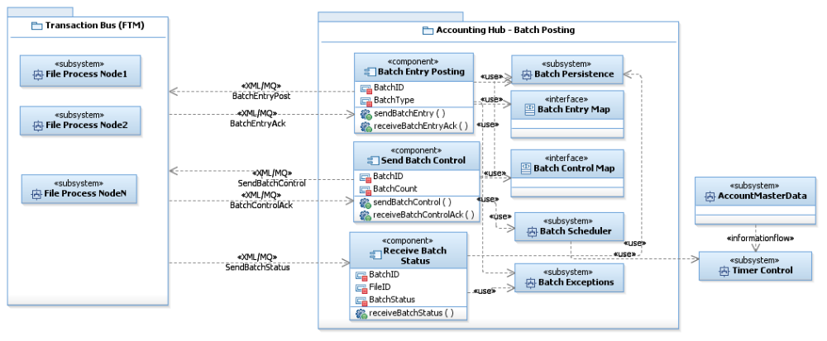
- BatchEntryPost is the primary interface newly proposed to send batch entries to Transaction Bus. This interface will expect an acknowledgement from Transaction Bus to check the status of transaction – whether the batch entry was accepted by Transaction Bus or not (possible Transaction bus technical exceptions).
- SendBatchControl is the batch trigger message that signals Transaction Bus to start bulking and prepare files for product platforms. There could be scenarios of simple time-triggered bulking without header/trailer when Transaction Bus could manage the batch trigger internally. This interface also would have an acknowledgement for Accounting Hub to know the status of batch acceptance.
- SendBatchStatus is an offline fire-forget interface for Transaction bus to send actual processed batch status back to Accounting Hub. This will enable Accounting Hub to complete the processing of batch and mark the transactions part of batch as completed.

Batch Entry Posting – Activity Diagram
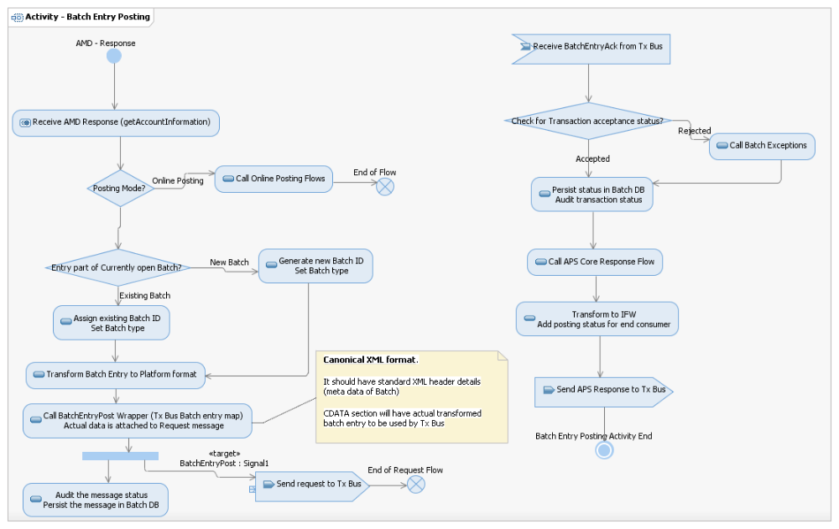
- The flow for sending batch entry is generally triggered off by decision on AMD response for getAccountInformation.
- If the posting mode is online, the regular product platform posting is continued.
- If the posting mode is batch, if required a new batch id is assigned otherwise an existing id is chosen and assigned. Related batch details are fetched from configuration previously obtained in AMD response flow.
- Batch entry (data record) is transformed into required platform format and included into XML request as a CDATA section
- The canonical XML format (newly proposed) will hold header and details information for Transaction Bus to completely understand the batch details and accept entries for batches.
- BatchEntryAck is an offline acknowledgement flow to receive and store batch entry acceptance from Transaction Bus. If there are any issues in Transaction bus accepting for batches, those entries will be updated as “batch not completed” in Batch DB and response (APS IFW) created accordingly to notify the consumer of account posting.
- APS response is produced only after receipt of acknowledgement from Transaction Bus regarding status of transaction accepted into batch process.

Send Batch Control – Activity Diagram
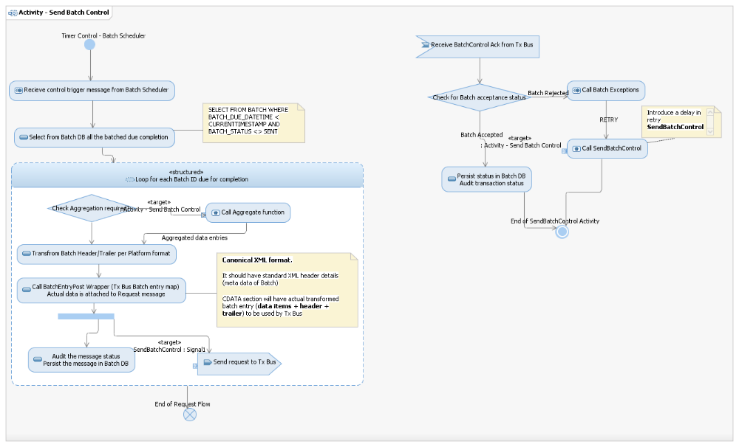
- The flow for sending batch control or trigger for a batch completion is generally triggered off by timer control and batch scheduler. Batch scheduler would have used the reference information from previously called getAccountInformation (AMD response)
- First step, DB is queried to fetch all the batch details that are currently due for completion.
- Looping through every single batch record (batch ID), the following steps are followed.
- Check if Aggregation is required for the account setup (based on AMD reference data – accounting model). If required, aggregate function is called for necessary generation of aggregated entries.
- Required product platform maps are called to produce header + trailer + aggregated data entries transformed into platform format. This will be packaged into CDATA section as protected data for Transaction bus to use.
- The newly proposed XML canonical message will include details of batch, product platform and other relevant information.
- BatchControlAck is an offline acknowledgement flow to receive and store batch trigger acceptance from Transaction Bus. If there are any issues in Transaction bus accepting for batch trigger, those entries will be updated as “batch not triggered” and retried after a configurable delay.
- At the back of successful batch acceptance, the entries are persisted and audited into Batch DB.

Send Batch Status – Activity Diagram
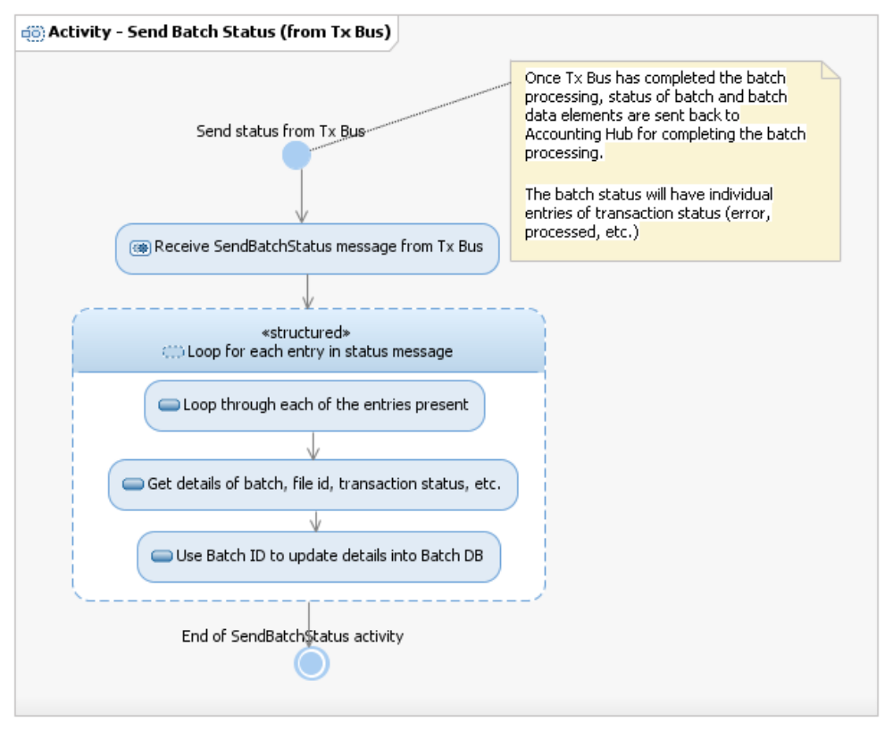
- This flow is a simple fire-forget from Transaction Bus for sending batch completion status back to Accounting Hub
- The batch status may contain multiple transactions reported on as there is a potential for some transactions not successfully bulked by Transaction Bus.
- Looping through every single batch record reported back, the flow will update details into DB and audit information.

Transaction Context Management
- Accounting Hub should persist the context of transactions in the data store for effective management of context and grouping across the life cycle of every single transaction processed through Accounting Hub services.
- A unique parent transaction ID will be maintained for every context, if required new child transaction ID will be created and tracked until the group is completed and the parent transaction will be updated once all the child transactions are completed.
- The transaction context at each stage is used for dual purpose – tracking and completion of groups or batches; failure recovery from the state when the failure had occurred.
- At high level the proposal is for creating a reusable component/subflow named as TCM (Transaction Context Manager) will be developed to implement this functionality.

Transaction Context Manager (TCM) Flow
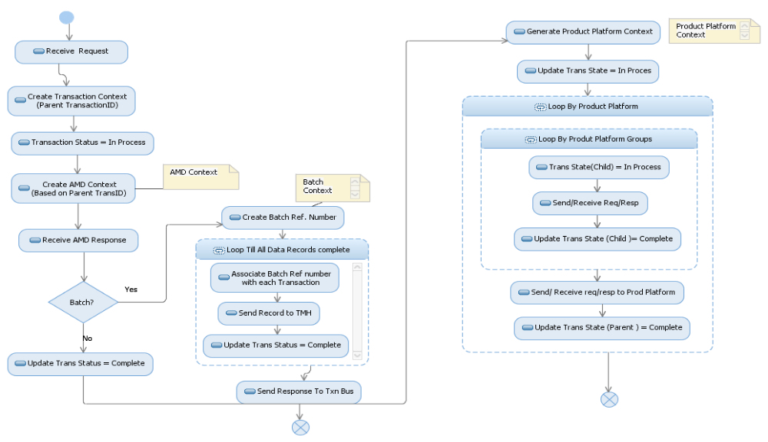
- Every request and response transaction that is coming into and going out of Accounting Hub platform will be tracked and ensured that a complete end to end tracking is available in the data store.
- A Transaction Context with a Transaction ID is created when a request is received from consumer.
- AMD Context - The original Transaction ID will be used create the context. There will be only one context for both getAdditionalAccount Information and getNPADetails.
- Batch posting context, create a batch Reference Number. Associate this batch reference number to all the data that is being sent to Transaction Bus. Update the Transaction Status as ‘Complete’ once all the data is sent to Transaction Bus.
- Product Platform Context – Product platform context will be created and initially assigned the status as ‘In Process’. A Child Trans Id will be created for the product platform groups. Initially the Trans state for child will be set to ‘In Process’. Once request sent to each group and response received, then child trans state will be set to ‘Complete’. The same process will be followed for each of product platforms in sequence. Finally the Trans state of the product platform context will be updated to ‘Complete’ state once responses from all product platforms are received.

Recovery of Failed message based on TCM
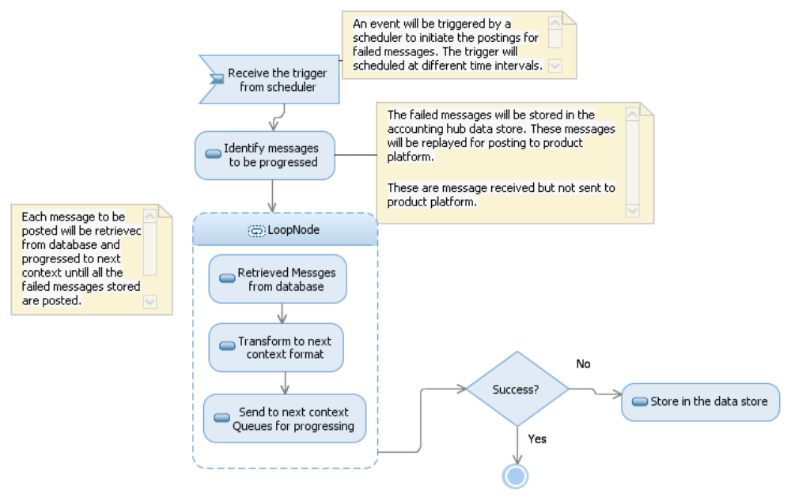
- All the posting messages which are received but not posted to product platform are stored in the Accounting Hub data base along with product platform information.
- A scheduler will be configured to trigger at pre configured frequencies.
- Accounting Hub will receive the trigger from the scheduler and will initiate the process.
- All the messages which are received but not posted to product platform will be retrieved from the database.
- Each message which is failed will be having current context and the next context. The failed messages have to progress from current context to next context.
- These posting messages will be transformed to the next context format and will be sent to a defined queue.
- If the posting is success the next message will be retrieved from the data base and will be progressed to the next context. The successful message will be deleted from the database.
- This process will continue till all the messages stored in the database will be posted successfully.
- The failed messages will be handled by the exception handler and stored in the database. An appropriate response will be sent to the consumer

Non-Functional Requirements
The following table shows the volumetric information for each of the message types. The volumes mentioned in this section may be refined after the Payment workstreams provide more detailed requirements
Payment Scheme | Account enquiry (day) | Account Posting (day) | Time window
International | 800 | 800 | Chaps processing window
CHAPS | 50 | 50 | International processing window
Clearings | 100,000 | 100,000 | Batch to be posted after midnight
The following are the volumes which would need to go to rCBS
Payment Scheme | Account enquiry (day) | Account Posting (day) | Time window
International | 50000 (already covered by ePayments) | 50000 | Chaps processing window
CHAPS | 60000 | 60000 | International processing window
Key Notes:
- The projected NFR for IT Resilience (both enabler and payment engine projects) will be on top of existing non-functional capabilities of Accounting Hub services
- The NFT testing should prove both existing and additional capabilities.

Component Details

- The entire set of components described in section 3 will have to be built – mostly reused from within existin framework.
- Detailed design will confirm how much of current code base and existing components can be reused, but following is an indicative list -
  - – currently developed can be reused
  - Interface Maps – most of the maps are retained (almost 100%)
  - Flow controller, MapRouter – new components
  - Clients
  - Microkernel
Sl No | Microkernel components | Existing components | Reuse / Develop
1 | Hub Adapters | MQ_SENDER_SF, HTTP_SENDER_SF | Reuse and modify
2 | AIS and APS Interface handler | AIS_CORE_REQ, APS_CORE_REQ | New but some reuse
3 | Flow controller | None | New
4 | Map Router | None | New
5 | Audit, Exceptions | ACH_AUDIT_MF, ACH_EXCEPTIONS_MF | Reuse
6 | Group Controller | AIS_GROUP_CONTROLLER_MF,  AIS group flows | Reuse, modify
7 | Interface Maps | All API maps | Reuse
8 | Batch interfaces | None | New
9 | Aggregation | None | New

New Component Details

Account Enquiry to HBOS
Component Name New
Account Enquiry To HBOS
Brief Description
It is a generic service. The existing core service will be modified to get the balance and status of accounts from HBOS product platforms. Will receive Account Enquiry request from Payment Engine.
Interact with the HBOS Product platforms like wCBS, NCA, TD01 and IF-Midtier platforms. Send the acknowledgement back to the service consumer
Purpose and Context
- Service to abstract the interaction with HBOS product platforms
Sub-activities
Request
- Receive the message from Payment Engine.
- Transform to IFW format
- Get the product platform information from AMD
- Send request to AMD and get additional & Meta data information about HBOS product platforms.
- Save the status of all the accounts and groups.
- Transform the IFW message to product platform format and route to product platform.
Response
- Receive Product Platform response
- Transform the response to IFW format
- Send the response to Payment Engine.

Account Posting to HBOS
Component Name New
Account Posting to HBO
Brief Description
It is a generic service. The existing core service will be modified to post the entries to HBOS Platforms. Will receive Account posting request from Payment Engine/TMH. Post to HBOS Product platforms like wCBS, NCA, TD01 and IF-Midtier platforms. Send the acknowledgement back to the service consumer
Purpose and Context
- Component to apply account posting to HBOS product platforms.
- Post settlement/contras to Contra product platforms.
Sub-activities
Request
- Receive the posting request from Payment engine/TMH.
- Transform the message to IFW format.
- Receive HBOS product platform id, additional account information from AMD
- Receive platform groups, sequences, posting type, posting mode from getNPADetails call to AMD.
- Post the customer postings to product platforms
- Post settlement/contra entries to contra platforms.
- Send success response back to Payment engine. In case of failure send the exception message back.

Aggregation
Component Name New
Aggregation.
Brief Description
Some payments have to be aggregated before sending them to product platform. AMD will send the Posting Mode field depending on which Accounting Hub will do the aggregation.
Purpose and Context
- Component to aggregate payments and post to product/contra platforms.

Sub-activities
Request
- Receive the trigger message from scheduler.
- Retrieve the postings to be aggregated from the data store.
- Perform the aggregation based on the rule.
- Transform it to product platform specific format.
- Do the posting to product platform or contra platform.

Batch Posting

Component Name New
Batch Posting Handler
Brief Description
There is a requirement from HBOS product platforms for file posting. Platform expects the posting instructions to be sent in files. This component is responsible for sending the postings which have to be sent in files, to Transaction Bus. Transaction Bus in turn will create the file and send to product platforms.
Purpose and Context
- To do Batch posting to HBOS product platforms.

Sub-activities
- Receive AMD response
- If the Posting Mode is batch, consolidate all those account details which have to be sent in batches.
- Transform it to Transaction Bus format.(TBD)
- Send to Transaction Bus
- Transaction bus, in turn will consolidate all the entries for a product platform, create files and send directly to HBOS product platforms.

Interfacing with TMS – Alerting NPA Failures
There is a requirement to report exceptions to the business when there is a failure to post to a NPA (however the customer part of the transaction has processed correctly ). Accounting Hub will handle such exceptions and alert to the Business. For NPA failures in Accounting Hub, will send alert request to TMS (Task Management System) to create an automatic task by passing sufficient details of failure to Business team, so that they could make the failed postings manually

Frame Work Changes
The existing exception frame will be extended to handle NPA alerts to TMS. As per BAU, whenever there is an exception, the exception will be recorded in the exception database. This framework will be modified so that if the destination is TMS, it will be handled by TMS Interface Handler. A new TMS handler will be developed to handle request and responses to TMS.
However, the framework of the existing transaction processing will not be affected.

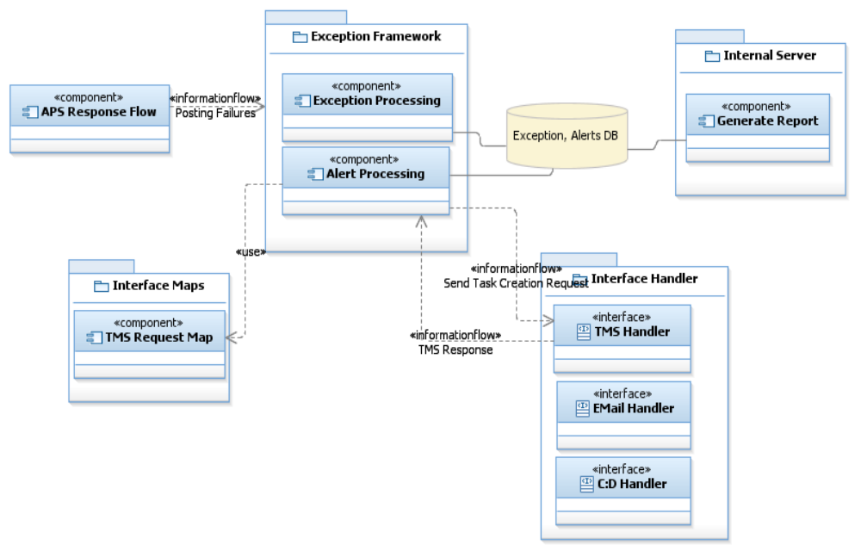

Alerting - Activity Diagram

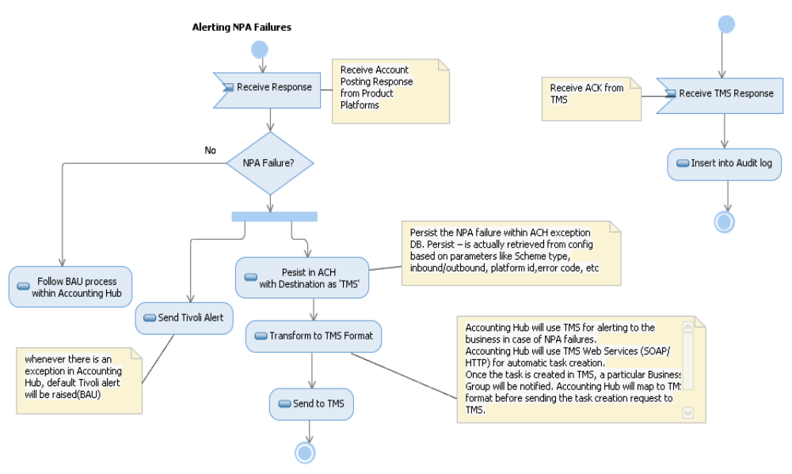

- Accounting Hub will make the postings to Accounting platforms.
- Retrieve response messages from platforms for the previously issued account posting requests
- If there are any exceptions on failed postings, pass them through standard IFW response mapping as well as route to Exceptions framework as per existing design
- Accounting Hub will call TMS to create an automatic task.
- Accounting Hub will transform the message into TMS format before invoking TMS.
- The message is of type described in the attached document
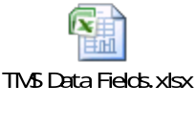
- Accounting Hub will use TMS Web Services (SOAP/HTTP) for automatic task creation.
- Once the task is created in TMS, a particular Business Group (TBD) will be notified.
- Business team should be able to see all the data attributes passed from the Accounting Hub as part of the failure.
- Business team will use these details and perform necessary reconciliation/adjustment tasks based on the trigger from TMS task.
- Receive Response from TMS (ACK/NACK)
- Update the audit table with TMS response.
- End of the day all the NPA failures(destined to TMS) will be extracted from DB.
- An EOD report will be created and sent to the business team(TBD).
- The report will be created based on the BATCH model defined in Micro Kernel framework of Accounting Hub.

  - AMD Interface Changes and TD01 Posting Orchestration.

- TD01 Posting : - Changes are required in Accounting Hub in order to replace the sort code and account number with the ENo as per the TE42 parameter file for making the 0200052 Oracle GL credit postings from Accounting Hub. Changes are required to use correct JE description field as per the TE42 parameter table.
Solution:-
- Rework on mapping
- Cashier Balance: – Changes are required in Accounting Hub in order to make the cashier balance postings. The requirement is to accumulate cashier balance and send to TD01.
Solution:-
- Create new mapping for cashier balance request and response.
- Modify the existing orchestration of TD01 postings to accommodate Cashier balance.
- Accounting Hub will accumulate cashier balance throughout the day and post the cumulative cashier balance only one time at the end the day.
- when accumulated posting for all payments in a day is equal or more than £1bn, this will post but as 9 digit only, the leading digit will be removed. In addition where TD01 Cashier Balance is more than 9 digits that a technical alert is raised in the Accounting Hub. Nothing will be done with this alert. It will be refered by business if needed.

- Brand Details : -Changes are required to AMD and Accounting Hub to identify Brand and use the branding details to derive posting entries. The ALS call will provide the brand related details. Changes are required to AMD and Accounting Hub to identify Brand and use the branding details to derive posting entries. The ALS call will provide the brand related details. The brand identification is required for TD01 postings – to identify BoS and Hfx brands in order to get the corresponding E-No for making the contra postings into Oracle GL.Once these changes are made to get the brand details, the same functionality will be re-used for Sainsbury’s account postings.
Solution:-
- AMD to send the brand details to Accounting Hub which in turn will map to the request sent to product platforms by Accounting Hub.
- Channel Identifier : FTM will send the Channel Identifier and Transaction Sub Type in order to derive the correct posting entries for hHBOS postings for both inbound and outbound payments.
  - Channel Indicator will be passed from FTM to Accounting Hub in APS Request. The channel indicator field (channel-indicator) is already available in APS Request. No schema changes required. FTM will pass values based on the channel from which the payment is made. This is required in AMD to differentiate the account postings from channels COL and IF Mid-Tier.
  - Transaction Sub Type will be passed from FTM to Accounting Hub in APS Request. The transaction sub type field (Tran-sub-type) is already available in APS Request. No schema changes required. FTM will pass values (inbound or outbound) based on the channel from which the payment is made. This is required in AMD to differentiate the account postings for inbound and outbound payments correctly.
Solution:-
- Rework on mapping

Information Architecture
The overall Information architecture has been layed out as below in the diagram. The details of each interfaces will be covered as part of IT BA analyis and study. References to existing interfaces are provided, not the final list.
Key points:
- IFW request / response structure to be retained
- getNPADetails response from AMD will have more details that aid multiple / inter-platform posting and compensation in case of failures
- TCM model houses the critical attributes utilized to track a transaction – transaction context manager
- Batch interfaces will use new XML based canonical model with headers and payload packaged as character data (CDATA) to be used as-is by TMH for batch posting
- Policy model is defined, further details will be added later, to cover dynamic routing and carrying policy information across the transaction life cycle for components to utilize data
- HBOS platform interfaces and specification will be referenced from artefacts provided by IT BA separately

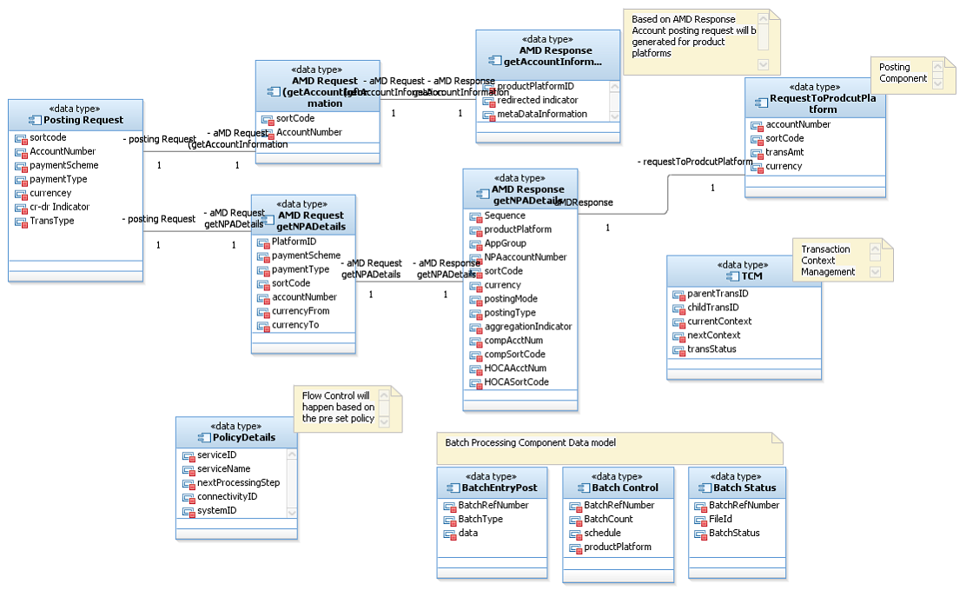

IFW – Request Layout
There are no changes perceived for IFW request messages both AIS & APS
http://teamspace.intranet.group/sites/ADMSOAServices/Services%20Documentation/TBT-SOC/Payments/Service%20Design/ACHub_retievePostingArrangementsDetails/ArrangementReporting_RetrievePostingArrangementsDetails%20-%20Service%20Design%20v1.0.doc

IFW – Response Layout
There are no changes perceived for IFW response messages both AIS & APS
http://teamspace.intranet.group/sites/ADMSOAServices/Services%20Documentation/TBT-SOC/Payments/Service%20Design/ACHub_retievePostingArrangementsDetails/ArrangementReporting_RetrievePostingArrangementsDetails%20-%20Service%20Design%20v1.0.doc

Batch Posting – Message Layout
New interface design built for batch posting interfaces between AHUB and Transaction Bus.
<< Link to be pasted >>

AMD – Request and Response getAccountInformation
New interface design built for getAccountInformation interface between AHUB and AMD.
<< Link to be pasted >>

AMD – Request and Response getNPADetails
New interface design built for getNPADetails interface between AHUB and Transaction Bus.
<< Link to be pasted >>

Error Codes
All the error codes from the product platforms and the corresponding Accounting Hub error codes are listed in the document in the below URL.. This list is prepared by BA/EAD team and will be updated for the new error codes for IT Resilience-HBOS Product Platforms.
http://projectspace.intranet.group/sites/GlobalPaymentsHub/AH/P1/Design/Interface%20Specification/AHUB_ErrorCodes_v0.5.xls

Response Code/Message
Accounting Hub will provide the response code/message at account level as well as group level for a group of accounts. Below table shows the expected behaviour. There will be response code & message for the overall request/response message and an account level response code & message for each account in the request.

ResponseCode | It is the Account level response code which gives the state of the Account Response
ResponseMessage | It is the Account Level response message corresponding to the Account response code which gives the state of the Account response.
Account Detail
ResponseCode | It is the overall response code which gives the state of the overall response.  The overall response code will be mapped with fixed value based on the types of responses Accounting Hub receives from the backend.  Following are the values:  111111: Successful. This code will be mapped when Accounting Hub receives responses for all its account enquiries sent to the downstream applications.  222222: Partially Successful. This code will be mapped when Accounting Hub receives at least 1 failure at account level from any of the downstream applications.  333333: Failure: This code will be mapped when Accounting Hub receives failure for all accounts requests to the downstream applications (either at individual level or at overall level from downstream applications).  555555: Accounting Hub due to any technical issue is not able to generate and send the request message to the downstream applications.
ResponseMessage | It is the overall response message corresponding to the overall response code which gives the state of the overall response.

Security

The MQ Queues will be accessed over a SSLised connection. The message will not be encrypted.
Refer the corresponding sections of the latest version of AD document located in SharePoint.

Scheduler and Mainframe
Not applicable for this requirement

BAM Monitoring

Requirement
- BAM is the Business Activity Monitoring and has the ability to monitor systems at a high level via a number of low level techniques.
- The primary techniques that the Accounting Hub is intending to use are WMQ monitoring, therefore the BAM Solution does not need to integrate with the Application Layer directly to reduce cross system dependencies
- Implementation and realisation of BAM monitors are out of scope of this project and will be delivered as part of the D6 – Business Activity Monitoring ABB

Operations Monitoring

Requirement
- Operations team (IT Support) will be responsible for proactive monitoring of the Accounting Hub.
- They require notifications of issues to deal with initial incident and could call ADM Support if required.
- Combination of Tivoli Workload schedule failures (TWS) and Tivoli Event Console messages are to be used.
- The ADM Payments - Support is responsible for reactive monitoring and maintenance of Accounting Hub instances
- Operations monitoring requires alerts and notifications to the team in cases of failures, deviation from normal routine, changes to critical path of message flow, etc.
- The primary monitoring mechanism to be implemented will utilize WMQ messages flowing through the Accounting hub components
- A copy of incoming requests are stored in an offline WMQ and removed at the end of account entry processing. This will aid to track the overall completion time, individual processing time, etc.
- ADM team should have the ability to view real-time status of Accounting Hub, overview of currently running processes, drilled down reports and performance trends of overall patterns and modules
- All Support and Monitoring must be captured within an Application Support Manual for the ADM support team and an Operational Support Manual for Operations support.

Implementation
- Auditing and Exception handling modules form the major inputs to support team in terms of logging and audit mechanisms.
- Some of the WMQ features and monitoring queues could be used to capture statistics about the messages flows like throughput of a transaction, end to end execution time, time lag, etc.
- There should be an ability to configure various levels of severity and resolution codes for each of the application and deviations or exceptions.
- Following are some of the issues or situations to be covered as part of Operations monitoring
  - Message life-time in a queue, i.e. monitor queues for messages not getting processed
  - Communication failures at endpoints connecting to product platforms
  - TWS work schedule failures

Exception Handling

Requirement
- The Exception handling for whole of Accounting Hub should be decoupled from the main message flows
- The main critical path flow should just process, on failure, throw the error to a compensation flow to handle exception
- Exception at operation level will not be handled by Accounting Hub. It will be handled by Transaction Bus.

Exceptions Data Store
- Common data store could be used and shared between exception handling and auditing
- Tables specific for Exceptions, exception description, exception rules have to be designed

Implementation
- Set of flows and sub flows to achieve offline handling of exceptions
- All the required functional main flows would push exception messages across to a common exception queue – LQ.AH.ERROR.IN

Auditing

Requirement
- The end to end flow of transaction from source system to Product platforms passed through Accounting Hub needs to be audited.
- A centralized audit database is used to store audit information for all services within Accounting Hub.
- Only certain predetermined components are audited in the message flow.
- Incoming messages from Payment Engine will be stored in the Accounting Hub. These extracts can be provided upon request to Payment Engine/TMH.
- Three levels of audit events are recorded – Information, Warning and Exception
- Information Event: This is an audit trail of service or component calls, i.e. every call to independent modules are recorded
- Warning Event: For every call to modules or services, if there are deviations in expected result, then those are recorded as warnings
- Exception Event: Every failure within modules or service to be recorded as Exception events. Exception module should be offline to main message flow and record exceptions to aid real time exception investigation even if the main flow doesn’t complete processing.

Infrastructure Design
Refer to the corresponding sections of the latest version of MLPD document – “Accounting Hub Configuration Management Mid-Level Platform Design” located in SharePoint.
Here is a very high level snapshot of infrastructure implementation of Accounting Hub.
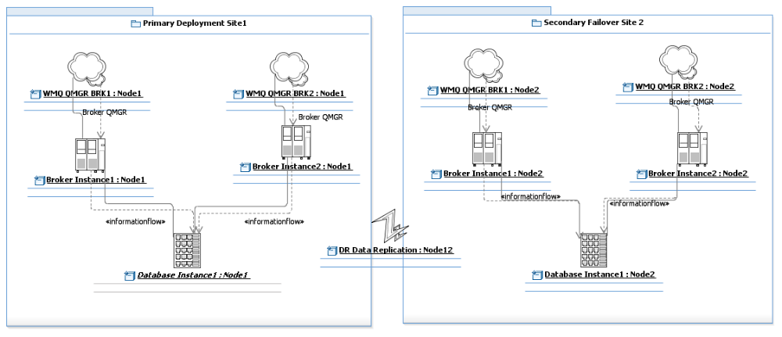
This is further drilled down into broker architecture as below. Note: The detailed design / DPAD will complete the following architecture and performance testing will prove or drive for the number of execution groups to be cloned or number of message flows instances to be configured. The following represents the minimal setup for services implementation on Accounting Hub.
